**Agenda**

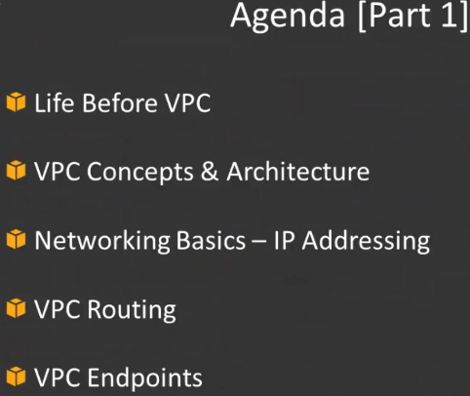

1. How things were before VPC actually came.

what was the need for VPC ?what does it solve ? what are the new things that it brings into AWS?

1. VPC concepts ..what is VPC and what the different components that VPC and architecture for VPC
2. go back a little bit into networking basics.. how IP addressing is done within the VPC ,CIDRlocks, private public IP addressing subnets.
3. routing aspect within VPC..How traffic is actually routed within the VPC
4. New functionality of VPC which is actually VPC endpoints.

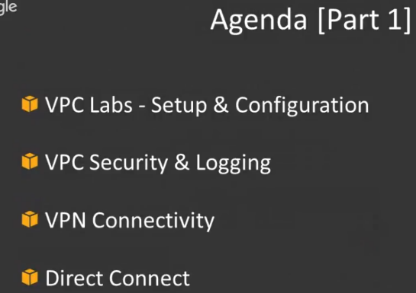

1. lab :set up a VPC and we'll do a little bit of testing with our ec2 instances.
2. different options you have in terms of securing your VPC and how do you log traffic that's flowing through your VPC
3. VPN connectivity and Direct Connect are two very extensive topics covered in much more detail in the part 2

**prerequisites** 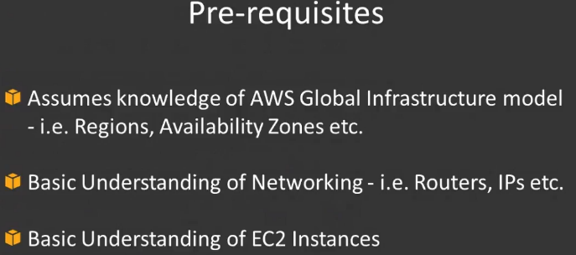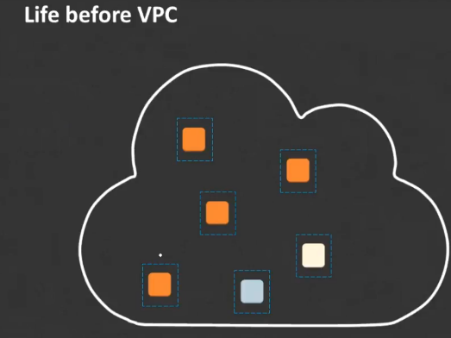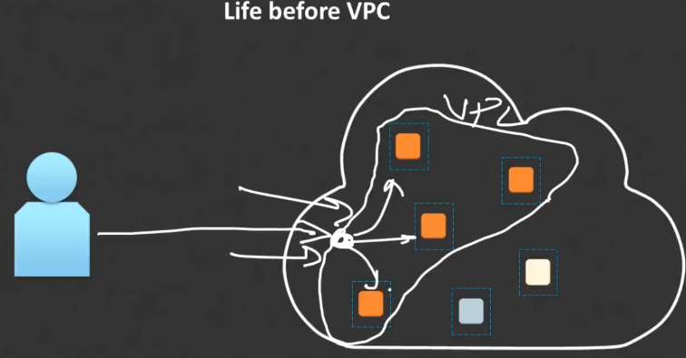

**VPC architecture**

Guys ,I want you to kind of burn this image into your memory because if you're ever going to be dealing with VPC this is kind of the first thing that you have to do in terms of architecting which means you have to kind of draw the diagram and how everything fits together.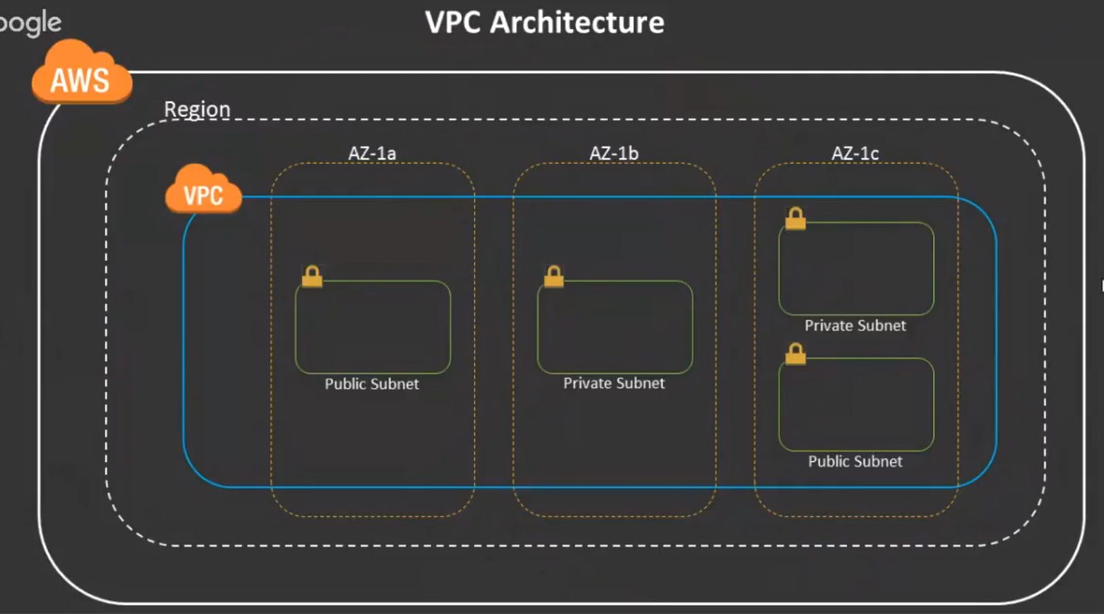

1.)In the outer layer you have AWS.

2.)Within AWS you have different regions …Mumbai region, US East region,US West region.

3.)Within your region you have all your availability zones.

Ex: a region with three availability zones. it's not that each region will have only… three there are some regions which have six availability zones… some which have five some which have three **but the minimum is two in a region.**

4.)When you create your VPC ..you are creating a VPC in the region. you can't create it within a particular availability zone.

When you create a VPC it stretches across all your availability zones.

5.) Within your availability zones, you create your subnets.It's not necessary that you have to use all your availability zones. you can just use two.

So let's take an example where you have the AZ-1c and you might not have any of these subnets this might just be blank.

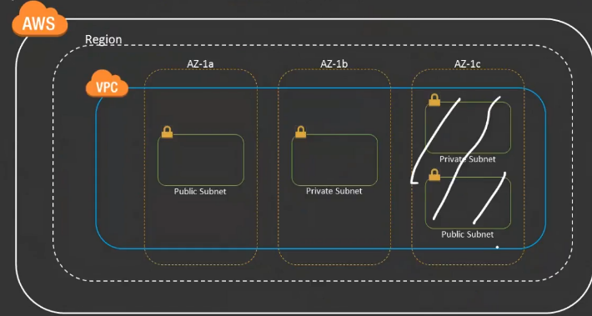

It's not necessary that you have to kind of have a subnets in all of your availability zones that's not necessary.

6.)You have your V C which stretches across all the availability zones but remember a VPC is always within a region.. it does not stretch across the regions.

7.)if you want Vpcs to connect together within different regions you use V PC peering, where you have a V PC in one region you have a VPC in another region and then you connect them together using V PC peering.

8.)You need to create public and private for your applications ..

a.)Put your databases in a subnet which doesn't have internet access .So we put your databases in your private subnet. Any servers that do not need access to the Internet right.. or should not be allowed access from the Internet you put them in something called a private subnet.

b.)all your web servers in public subnets

**Note:** when you create a subnet, there's nothing called a public or a private subnet.

i.) When you create a subnet ..,you just create a subnet.. Later on, when you start defining rules for your subnet that that subnet either becomes a private or a public subnet.

ii.)When you make a subnet public, you can later on change that and make it private or viceversa by changing routing information.

You will have your availability zones and your VPC will be stretching across all of these availability zones and you will have different subnets in all of these AZ..inside which you will place your systems.

**Components of a VPC:**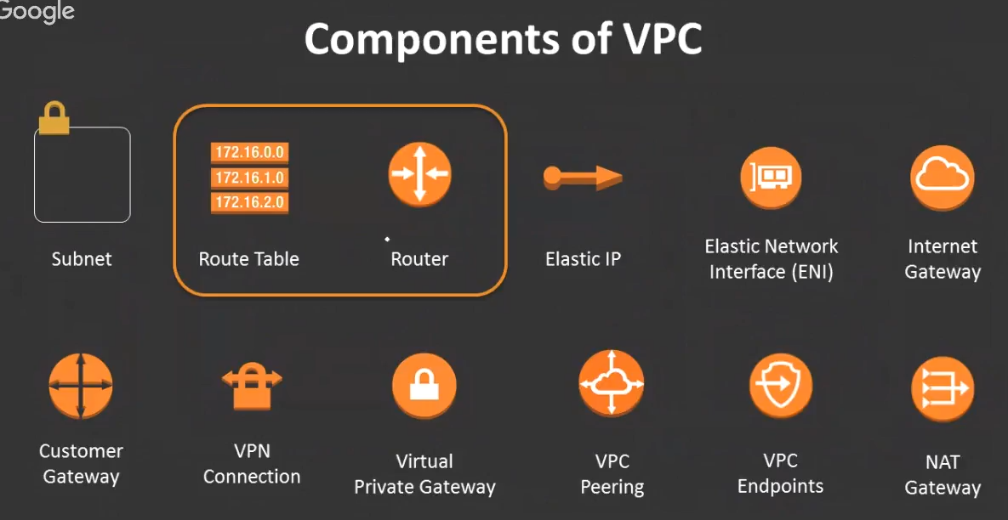

**Route tables and router:** Both are interconnected.

Router works by looking up information in the router table.

Router table basically holds information about where something should be sent .



* Ex: When some communication happens.., from IP address 10.0.0.10 and then that goes to IP address 10.2.0.5 .Information.., how this IP is supposed to communicate with this IP.. that information will be found on the router table.
* If there is no route that specifies, how does this IP go from this place to this place ..If there is no route specified in the router table then that communication won't work. The first system won't be able to reach the second system.

Ex: You have two systems..10.0.0.5, 10.0.0.6.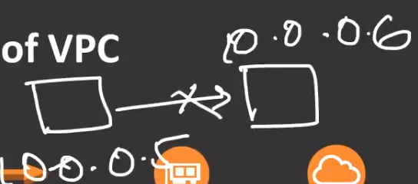

* There should be some information in the route table which says how can 5 communicate with 6 or which route does 5 take to communicate with 6.. If that information is not there this system cannot communicate with this syste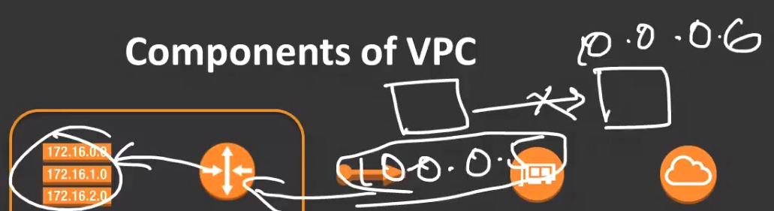
* When this system 10.0.0.5 makes requets to 10.0.0.6, that information gets into router, the router goes ahead and looks up the route table and ask the router table..,**how do I go to that system** How do I go from 10.0.0.5 to 10.0.0.6.
* If that information is there, then the router will go ahead and route the packets accordingly. If that information is not there obviously that communication is not going to happen …something like a request timed out.

**Route table holds information about how the routing happens and it's a router that routes based on that information in the route table..**

Whatever, you're seeing here almost everything is virtual devices..None of these are actual physical devices.Virtal devices that are built on top of physical machines.So it's not like a physical router that you're getting it's a virtual router that's there in your VPC.

**Elastic IP**

* elastic IP is basically a static public IP.
* Now when VPC came in, whenever you started an ec2 in the default VPC by default dynamically an IP address is assigned your Ec2. However that dynamic IP is not permanent. If you stop your system and start it that IP might change right. So rather than relying on dynamic IP s you can assign something called an elastic IP to your ec2 instance.
* When you do that your IP is permanent till you release that IP. You might want to have a public IP something like 50 6.15.20.9. OfCourse, you don't get to pick and choose but you will randomly get an IP address., that IP address will be assigned to your system.

Elastic IP and **ENI (elastic network interface)** work together.

* elastic network interface: it's I simply think of it as a network card.it's basically a virtual network card.
* it's kind of a Network port for your ec2 instance.
* So if you need network connection for your ec2 you have to have like a network card (elastic network interface)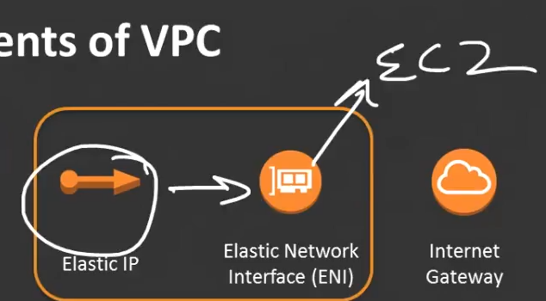

Whenever you are assigning IPs to your ec2 instances whether it's an elastic IP or a dynamic IP.., those IPS always get assigned to the interface and not to the actual ec2.

It does not get assigned to a particular ec2 instance as such but it gets assigned to the interface then this interface gets assigned to your ec2 instance.

* **what that means is:** let's say you have an ec2 that has two network interfaces (two elastic network interfaces) And, both of them have an elastic IP associated with the network interface.
* So, there is an elastic IP attached to this and there is an elastic IP attached to this network interface.

So essentially your ec2 has two public IP addresses that are static now.

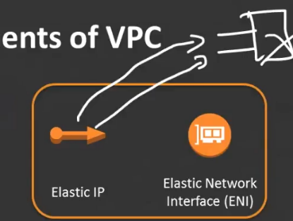

* Let's say something happen to this server it went down and that you're not able to fix it immediately.., if you can fix it but it's gonna take time ,and you only have one server you did something like that.
* Then you can easily go ahead and start up another server disconnect these network interfaces from this and reattach it to this system and you can continue using your existing IPs without having to change any other IP routing which means you don't have to go to DNS and change IPS or anything .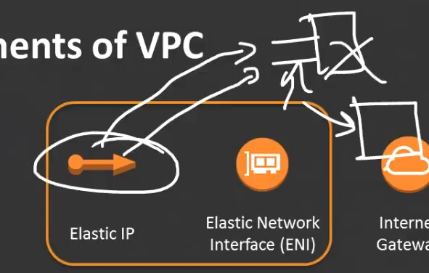
* you can just reattach the network interfaces from one system to the other and then you can continue using your existing IPs it's as if nothing happened .

You don't have to use new IPs for your new system you can continue using your existing IDs.

**Internet gateway** it's as simple as it says.. it's a gateway that allows you to connect to the internet .

* let's say you had an ec2 instance in your public subnet which is your web server now.. If this web server needs to talk to the Internet or if it needs to allow internet access there should be an Internet gateway that is configured in your VPC.
* So that when traffic comes in it comes in through your internet gateway and then goes to your V PC same way when traffic goes out it goes out to the Internet gateway and then goes out to the Internet. 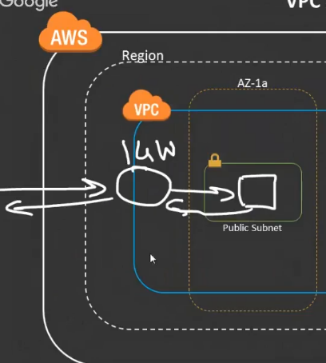
* An Internet gateway is nothing but like a door to your V PC that allows external communication to happen whether it is inbound external communication or outbound external communication.
* Internet gateways allows to communicate between tunnel and internal VPC.

**questions**

1. Can I create multiple VPCs in same region. yes
2. is subnet auto-created when we create ec2 instance or is it separate from the instance??

It is separate from the instance it's not auto created you you basically have to have a subnet in order to put your ec2. Your ec2 cannot just be placed randomly anywhere your ec2 has to be placed inside a subnet and then the subnet should already exist.

1. is the static routing or even dynamic routing protocols are supported too??

when we talk about VPN and Direct Connect we will talk about dynamic protocols like BGP and all of that but as of now within our VP C we are always going to deal with static routes.

BGP is supported for external connectivity like VPN and Direct Connect.

1. can Internet gateway connect with private subnet too?? We'll talk about how the systems inside the private subnet can get internet access that is not using the Internet gateway ..but we will talk about something called an NAT gateway.
2. how many static IP this can be attached to ENI limitation?? Think of it like an IP goes to one IP goes to one ENI.
3. elastic IP chargeable?? yes elastic IPS are chargeable there are some free limits guys there is a little bit of fine print so please look up the details as **elastic IPS are not chargeable as long as you have connected them to a working ec2 instance**.

But, you just have an elastic IP that is attached that is in your account but you have not attached that to any ec2 then you will be charged for that elastic IP.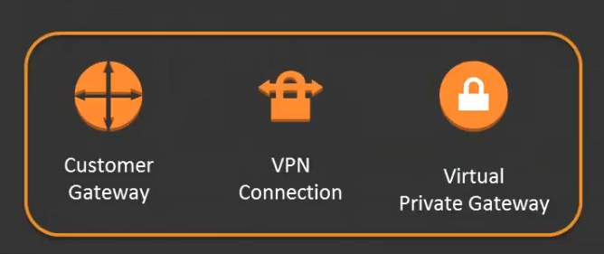

**Next Three components are customer gateway VPN connection and Virtual Private Gateway.**

The reason I told all of them together is because this is how you actually establish something called a VPN connection.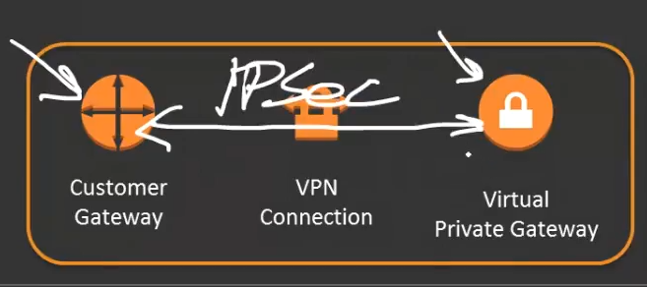

* If you need to establish a VPN connection, you need all of these three components to work together.
* On your side you will have your **customer gateway** which is nothing but your router in your premises right and then on the aws side there is a **virtual private gateway**
* You will basically use the VPN connectivity to establish a VPN connection between both of these endpoints.
* one endpoint is your customer gateway which is your router in your premises, and the other one is the virtual private gateway which is the router on the aws side or the Gateway on the aws side..
* you basically establish a IPSec VPN connection between these two endpoints .

**VPC peering** VPC peering is nothing but when you have two vpc’s together you connect both of them. You basically have to send a request first and then the other VPC accepts the request and then you have the connection there.

**VPC endpoints**:VPC endpoints are basically serve basically connectivity that allows you to talk to certain AWS services privately.

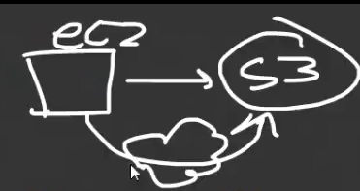

when you try to communicate from your ec2 to let's say something like an s3 service.

How it used to work is that s3 only had public endpoints which means when you talk to s3 from your ec2 it had to go out over the Internet right it was not a private communication.

It had to go out over the Internet and connect on the s3 public interface so whatever you are transmitting between your ec2 and your s3 buckets they were public.

It is not fully open as such but it was going over the public lines right which means that's not good if you are talking about data security.

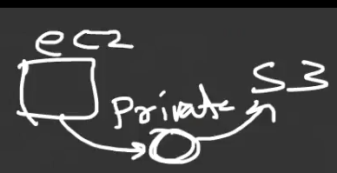

What VPC endpoints allow you to do is:

if you have the ec2 and you have the s3. You have the VPC endpoint.

It allows your ec2 to talk to the endpoint which talks to the s3 but this is private connectivity which means it doesn't go out through the internet.

So whatever you are transferring between your ec2 and your s3 buckets they're going to be in the private domain. They're not going to go out over the Internet.

**NAT GATEWAY**

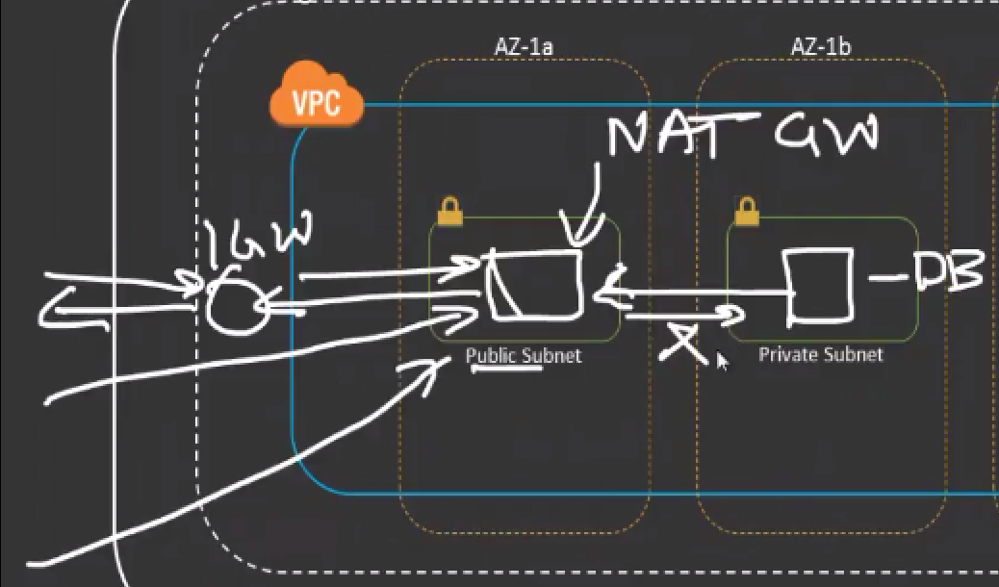

**Que:** why would private subnets need access to the Internet

Let's say you have your database here in your private subnet. database does not need to allow access into your database from the outside world.

However your database server is still a server and it needs updates and it needs patches right and the only way it can get that is by talking to the repository that are outside on the Internet.

So how do you get your internal ec2 systems that are in the private subnet how do you get them to talk to the Internet?? what you do is you use something called an NAT gateway.

You will have an NAT gateway now..

* NAT gateway basically sits in a public subnet.
* What the nat gateway allows you to do is it allows the DB to talk to the NAT gateway which forwards the communication then out to the internet gateway and then it can talk to the outside world.
* However the nat gateway will not allow any new communication to be initialized directly into the database. It's not going to allow that.
* **it will only allow the outbound connection and the reply on the same connection because it remembers what ported went out and it remembers that the request was actually made by the database.** So it will allow that request back in
* If the database is requesting for a patch for MySQL server then it will let that patch come back in because that request was made from the database from the private subnet.
* However it will not allow any new communication to be or any new connections to be initialized into the database.
* That's what the nat gateway does for you .

**IP addressing and subnets:**

1.) I'm gonna give you a single simple IP address that we almost deal with on a daily basis think OR your home network 192 .168. 100.201

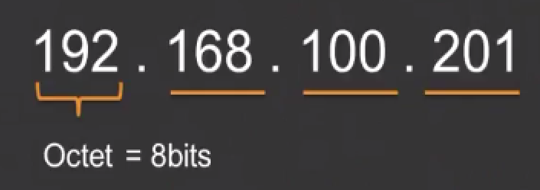

2.) In these IP addresses each of these are known as Octets.

They are known as Octets because each of them are made up of 8 bits.So Technically speaking each IP address is made out of 4 octet of 8 bits each.

3.)Now when we talk about bits, it is going to look something like this.

a.) So what you have here on the screen is this 8 bits actually represent the number 192.

b.)These 8 bits actually represent the number 168

c.)these 8 bits represent the number 100 and

d.)these 8 bits represent the number 2 0 1

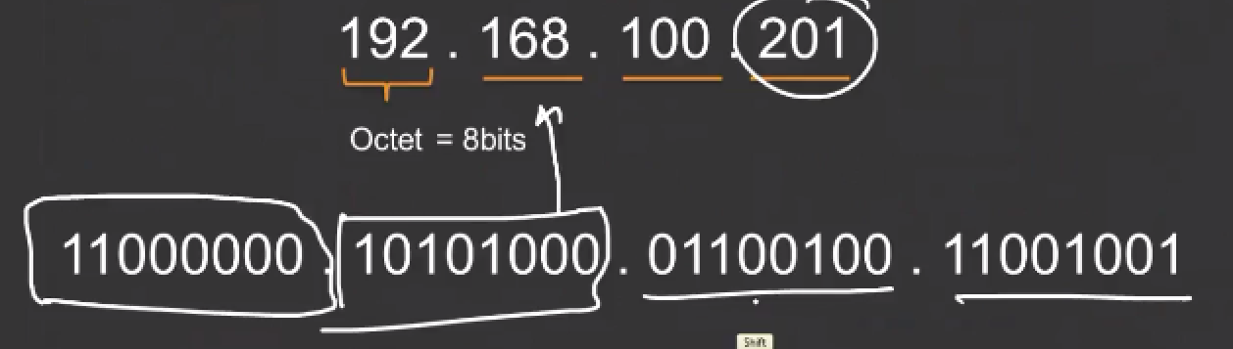

4.)Obviously You can change the bits around to represent different numbers.But each of the IP address in an IP addressing range it has 4 Octets and each of the octets are made out of eight bits.

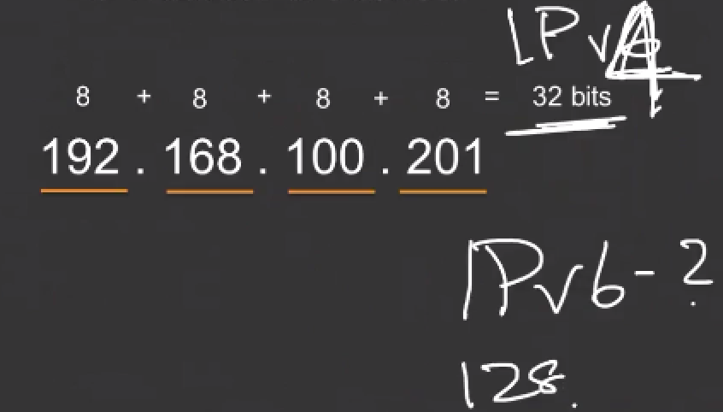

5.)Now what that means is that when you add all of this up: 8+8+8+8 = 32 bits

Thst’s why IPv4 addresses are basically 32 bit IP addresses.

Anybody know how many bits ipv6 is?? actually 128 bits.

So you have a lot more IP addresses.

6.)Now what I mean by that is this number 32 is important.., when you start talking about CIDR ranges and how you do IP addressing within a VPCs.

**IP CIDR range** : it's basically a notation or you write an IP address in a particular format so that when someone looks at that they know exactly .

* how many IPS are there in a network
* how large the network is and
* an additional information about that particular network

How you would write a CIDR range is something like this …

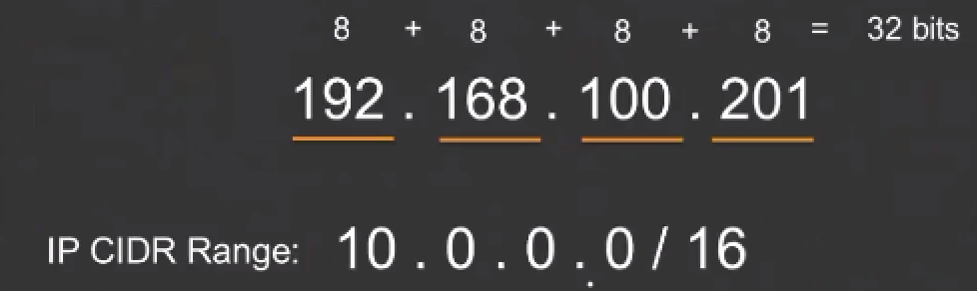

**so for example** this is a CIDR range and as you can see here it specifies an IP address(10.0.0.0.) and then it specifies a number(16).

Now this number(160 has a significance to this number up here(32 bits).

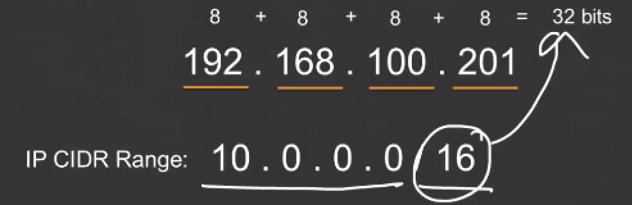

What this number 16 specifies is that first two octets of this(10.0.0.0) are not going to change.

Here's how it ….:here is 16 you need to start counting from the left side all right

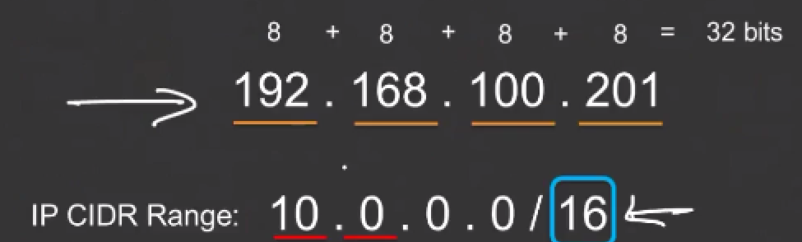

we know that each octet is 8 bits so we eliminated the first octet so we took out eight so how many remaining eight bits are remaining from the 16 so then I took out the second octet now.

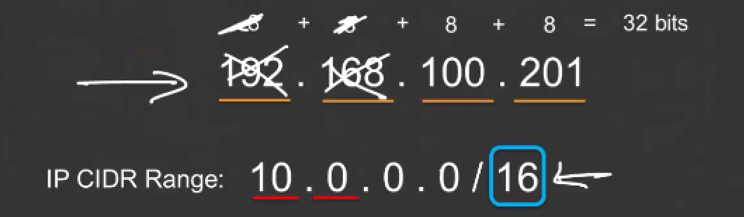

I have taken out 16 bits what this 16 is notating .**The first 16 bits of the IP address is not going to change in the IP range because when you write a CIDR range you are not actually specifying a single IP you are actually specifying a whole range of IP address.**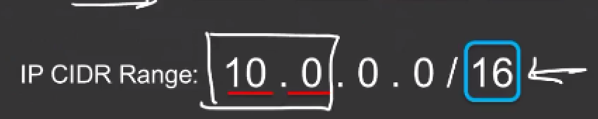

When I say / 16 actual range is going to be something like this which is 10.0.0.0 up to 10.0.255.255.

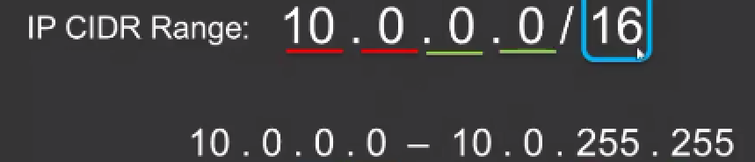 

The reason it's stopping at 255 is because the largest number that you can represent with 8 bits is 255.

If you need to represent the number 256 then you need 9 bits .

We know that each octet can only do maximum 8 bits that is why you always have an IP address with a maximum limit of 255.

let let me just revisit this here again I wrote an IP range which is 10.0.0.0 / 16. Now the 16 number signifies the number of bits that are not going to change.

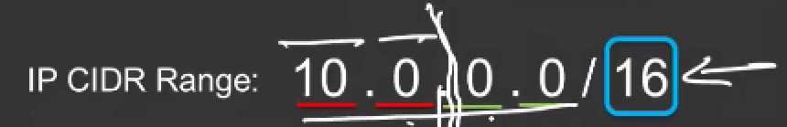

So I start counting I start counting 8 bits go on 8 more bits gone so now I know that this much part of the network is not going to change in the range.

So when I write the range the 1st two—Unchanged, last 2 changes..

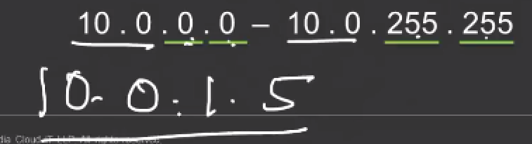

what this means is that there could be an IP 10.0.1.5.., is an IP address in this range

First 16 bits don't change ,remains constant. third and the fourth octet can change so there might be another IP like 10.0.15.9

🡪When say 10.0.0.0/16.. I'm specifying an entire IP range.

I'm telling that the first 16 bits in that range is not going to change, which means whenever I write an IP address in this range the first two octets will always remain the same.

Third and the fourth octet can be any numbers up to 255.255



Lets say I have an IP address range called 192.168.0.0 /24 what is the CIDR ?what is the IP range ? I don't want a single IP.. I want I want the entire range.

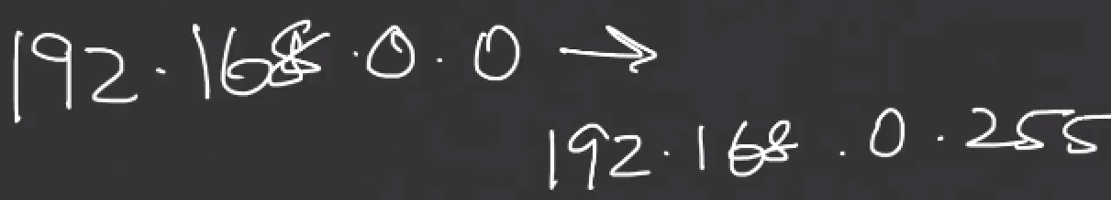

**Note** .0 is also an IP address in the range so it doesn't start from .1

24 bits of this IP address(19.2.168.0) is not going to change which means 8+ 8 + 8.



what that basically means is that in this CIDRrange the first three octest are not going t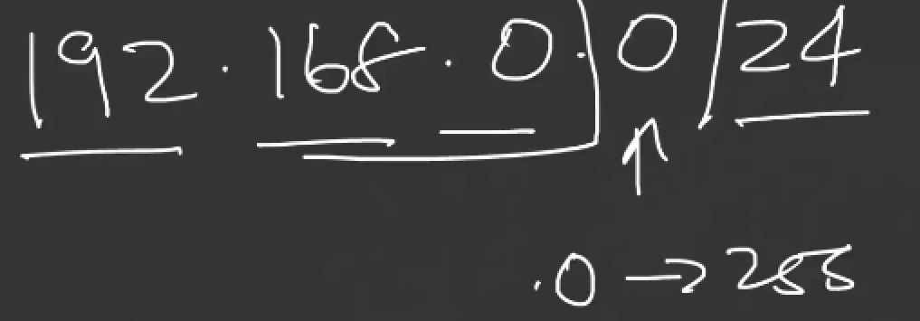o change. It is last octet that is going to change which means this can be anywhere from 0 up to 255.

**example** 192.168.0.1 or 0.15 , 0.21

* **CIDR**: it's basically a notation where you are specifying a particular range of IP addresses.
* When you create a VPC you have to specify CIDRrange of that VPC.

You're basically telling AWS that I am going to use X number of IP addresses to define this VPC.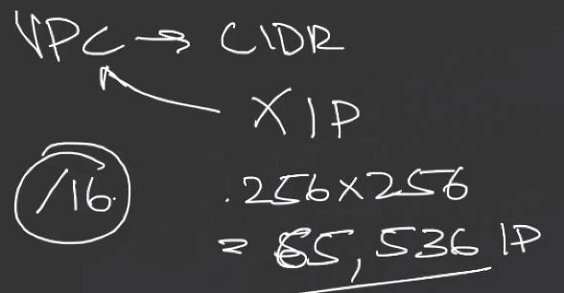

How large you make the VPC is actually very important because:

if I say a slash 16 ,that means two octects are going to change ..,third and the fourth.

Which means it can be **256 IPs * 256 IPs.**

That basically translates to a total of 65, 536 IPs .This the total number of IPs that you have in a /16 network.

When you specify the CIDR range for VPC **remember** you specify a CIDRrange in range that it has enough number of IP addresses so that you can assign it to all the systems but it also should not it also should not be so small that you actually run out of IP addresses.

**example** I I created a V PC and the CIDR 10.0.0.0 / 24. When I say / 24 it means the first three octets are not going to change it's only the last octet that changes.



There are 256 IPs in this VPC. I'm basically limiting my VPC to not more than 256 IPS.

So,when I create subnets I have to kind of divide those IPS into different smaller subnets then it's technically speaking I might not have more than 15 or 20 IP addresses per subnet that's that's not really good.

So you have to have VPC large enough so that you can assign enough IP addresses to all of your subnets.

**Question**: CAN CIDR range can be changed in a VPC later on?

Recently they introduced an option of additional CIDR ranges.

what that means is let's say you first made the mistake of doing this. You assigned a V PC CIDR of 10.0.0.0 / 24 now. What you can do is you can actually add an additional CIDR range 10.0.1.0/24 to VPC.

Now you have 256 + 256 IPS. 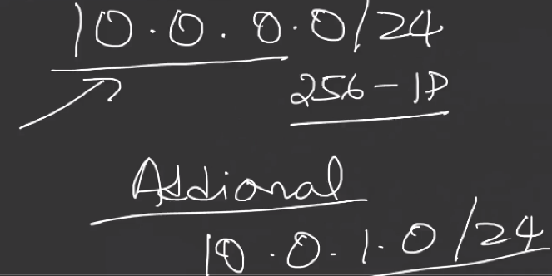

You cannot delete or modify or change your existing CIDR range but you can add additional CIDR range.

but obviously they should not be conflicting .The CIDRranges should be different from each other.

**Que**: What is CIDR range for 10.0.1.15 / 32 .can you tell me how many IP addresses are there in this? and what is the range of IP addresses?

/32 is basically specifying a single IP address .**Remember almost everywhere wherever you put in an IP address you have to write it in the CIDRnotation.**

For example, you basically want to allow only one IP address access to something. So when you do that you have to specify it in the CIDR range format you can't just put in I only want to give access to 10.0.1.15 rather you should specify it in the CIDR range because a / 32 means there is only one IP in this range.. and that IP is 10.0.1.15 .

**NOTE**:If you want to ever represent a single IP using the CIDRnotation you will actually do the /32.

**NOTE**: understand that when you write CIDR notations ,it is not necessary that it always has to be multiples of 8 .

it can be 21 it can be 19 .Does not need to be a multiple of eight.

Ex: 10.0.0.0/26. This is my CIDRrange it's 10.0.0.0/26 .

We're going to count eight plus eight plus eight so you've already counter 24 so what's remaining is two over here .

how this basically works is:

let's say for example there are 8 bits …1 1 0 0 1 0 1 0 0 1..These are 8 bits.

What basically happens here is the first 3 octets do not change that we already know because we have already discounted 24**. Now we need to also specify that the next to the next two bits in the last octet is not going to change**.

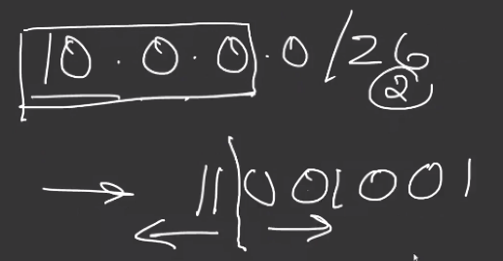

So what happens is these two bits(first two) are not going to change but the remaining six bits will actually change in the IP address .

This actually requires subnet calculators to understand.

Google🡪 subnet calculator .The best one that I would recommend is <http://jodies.de/ipcalc>

🡪Let's do 10.0.0.0 / 16.. I shows me what is the minimum(10.0.0.1) and what is the max(10.0.255.254).

Don't worry about these two five and all of that I will talk about usable IPs and non usable ip's but you see there is **basically a total IPS of 65534 .**

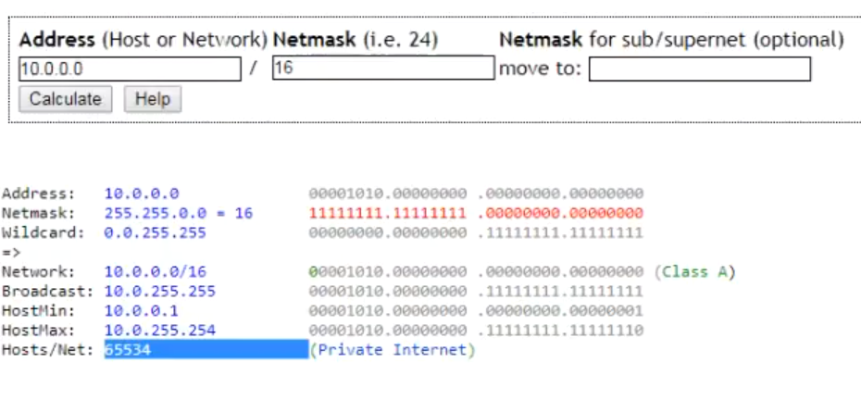

The first two octets of(HostMin and Hostmax) remain the same right because we are saying /16.

All these bits are exactly the same. It is only in this last two octets that it is actually changing.

🡪Now let's say I say 10.0.0.0 / 26.

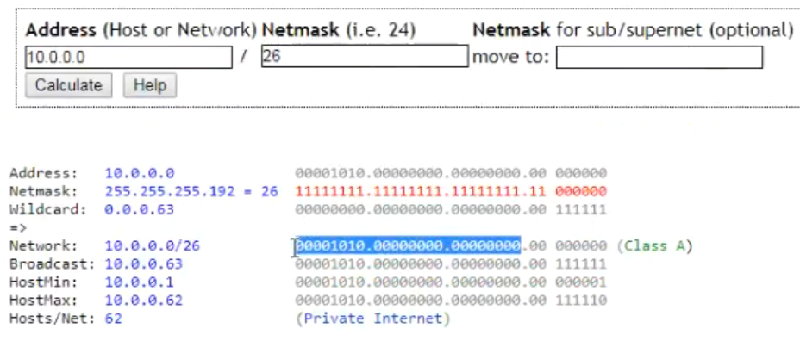

first second and the third octet does not change because out of that / 26 we have already taken out / 24 so that's not going to change.

But you see how it is actually separated out these two bits from the eight total bits of last octect.

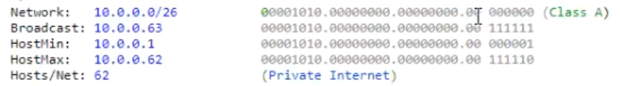

So if you see this is two bits plus six bits that is forming the total of eight bits.

So it's going to be something like this it's going to be like 10.0.0.1 to 10.0.0.62

It's not going to go up to 255 because the maximum number that you can represent with these many bits is 62.

If you are going deeper into the networking side of things and you have to do something that is not in multiples of 8 then you have your subnet calculator here.

However when you start dealing with VPCs and initially when you start working with them you will most probably be working with something like /16/24 etc …

**NOTE**: /16 is a larger network than a /24..which is obviously larger than 32 /



65536 IPS here……………………………….256 IP ………………………………………….1 IP here

**NOTE**:When you create your V pcs it's ideally better that you created with a slash 16 so that you later don't run into issues of not enough IP addresses.

**Having said that your V PC should be a maximum of /16 and a / 28.**

**you cannot have a VPC smaller than a /28 which means you cannot have a /31 or / 32 .Your V PC has to be in the range between /16 and / 28.**

**When you're specifying your IP addresses in the CIDR arrange for your Vpcs, you should actually be specifying it in the RFC 1918 standard ..which means you can have a 10.0.0.0/16.**

Remember that this is the RFC 1918 standard.. so a /8 or a /12 or a /16 that you see here does not mean that you have to apply exactly.

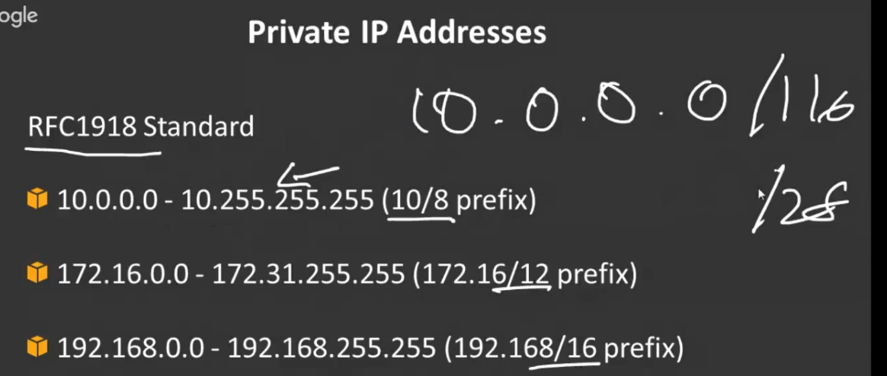

It is it is just saying that this range is possible which means if you go for a 10.0.0.0 range it has to be anywhere between the /16 to a /28 .

it has to be between that you can't go above slash 16 which means you can't go slash 15 / 14/13 etc you can't do that it has to be within the /16 to /28.

🡪 Same way you can do 172.16.0.0 . You can also do 192.168.0.0

You can bring in your own public IP addresses which means if you want your V PC to have your public IP addresses you can do that however you have to own those public IP addresses and then you have to go through AWS in order for the routing to be configured so that your public IP addresses are assigned on your VPC.

One more important thing that I have to mention here is that within a VPC, certain IP addresses are not usable right this applies to your subnets as well.

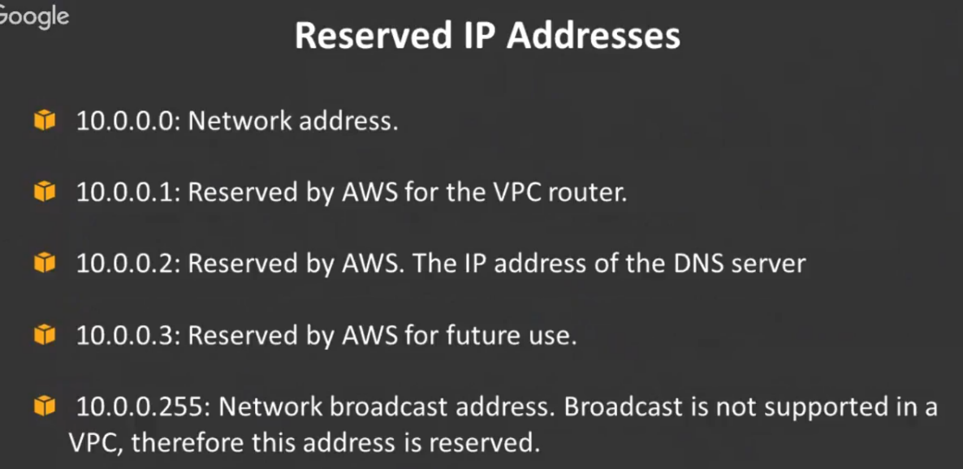

So in n your V PC the .0 , .1 ,.2,.3 and . 255 is not accessible regardless of whether it is a 10.0 or a 192.1 68 or a 172

They are reserved for certain things on AWS which means you cannot assign them to any particular ec2 instance or any service that you have.

**.0 and . 255 is generally not usable because the .0 is the IP of the base network and the .255 is the broadcast IP** address. Anyways broadcast is not supported within V PC so you don't have these two IPs anyways so out of 256.. if you remove 2 generally speaking in any network usable is 254 IPs.

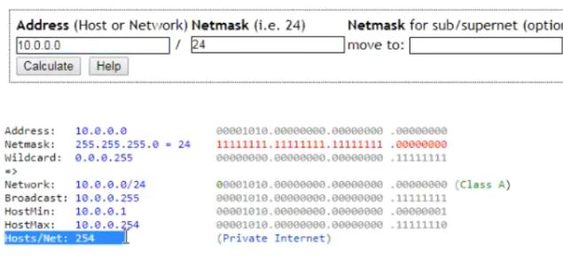

/24 has number of 254 IP address.

**Although Ip address, including the 0 and 255 is actually 256 but the usable is only 254 that's almost common in all the networks** .

Apart from these two IP addresses 3 more IP addresses are not usable within AWS Vpcs which is .1, .2 and .3 …

* .1 is reserved for the internal VPC router
* .2 is actually reserved for the internal DNS server that AWS provides
* .3 is not yet used for anything but it is reserved for anything that AWS might come out with in the future.

You have to use the RFC 1918 standard for the private IP addresses.

There is a default V PC available in every single region. This was created so that people who were using the classic ec2 which is before VPC I forgot to mention that was called classic ec2 which is before the VPC came in that's what it was called so people who wanted to migrate classic ec2 into the V PC AWS actually created a default VPC within every single region.

So if you go into your AWS dashboard and have a look at have a look at the Vpcs **you will always see at least one default VPC in each and every region.**

**Subnets**:

1.)let's say I have my VPC and my vpcs IP addressing CIDR range is 10.0.0.0 / 16 which means literally 65536 IPS are possible. But I definitely want to break it up into smaller chunks or subnets.

2.)Now I will have the different availability zones and in this example I am taking a VPC which has two availability zones in it .

3.)I will create subnets within both the availability zones.

**NOTE:** one important thing here to understand is that when you create the subnets.., the subnets are sub networks of your main VPC which means they have to fall within the IP range of your VPC .

VPC CIDR is 10.0.0.0 / 16. I need to break up this large network into smaller chunks.

Remember I told you that a 16 Network is larger than a 24 network .

So ideally speaking you can actually break this network into smaller chunks of /24.

**for example** let me break this down into 10.0.1.0/24 .

**Now my question is** is this 10.0.1.0/24 is this part of the main network?? is this actually an IP address in the main network ???

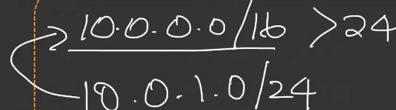

🡪It is part of the main Network. How do you identify if it's part of the same network??

You see the first network say /16 right which means the first and the second octet is not going to change.

Let me take a look at 10.0.1.0/24 …it says 10.0 is the same. So it's not changing is definitely part of my main network.

So whenever you are creating sub networks , you have to make sure that you are creating it as part of your main network.

**EX Que :** if you have a 10.0.0.0/16 Let me ask you this I'm going to create a subnet like 10.2.0.0/24.. is this subnet part of the same network?? can I create the subnet in this VPC??

🡪 it's not part of the same network because the 10.0.0.0/16 says firsts 16 bits always remainss same.. Which means it has to be 10.0 ..Not 10.2…

It's definitely not the same network. It's a different network. So you cannot create be part of your main network .

-🡪in this case I can go ahead and create 10.0.1.0/ 24. I can create a second subnet 10.0 .2.0/24.

Now obviously this second is also part of the main Network.

Also when you create subnets you have to create subnets that are not conflicting with each other.

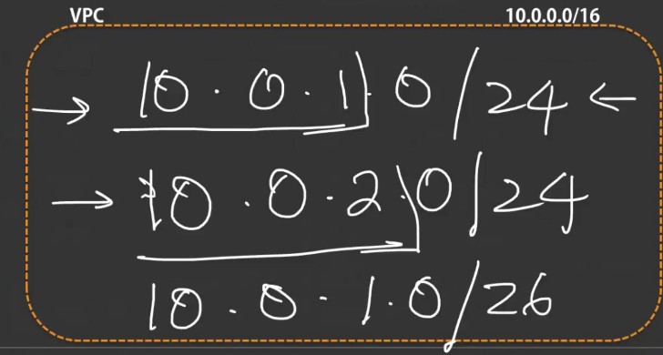

This network (10.0.1.0/24) is different from this network right because a /24 says the first three octects are going to remain the same.

now when I look at my second network(10.0.2.0/24) it is different.. It is not the same which means it's not going to conflict.**I cannot have another one here like 10.0.1.0/26**

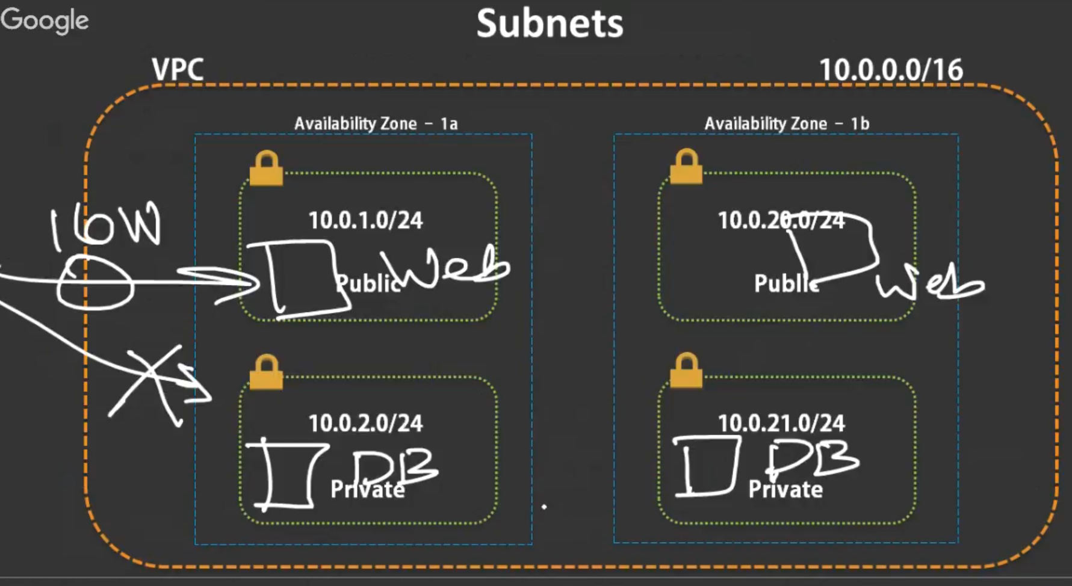

**NOTE:** B**ecause I already have a network saying /24 with 10.0.1.0/24 right. So I have create another network with the same range I cannot do that I cannot create another subnet because it's conflicting with the first one that I created .**

**SO when you create your subnets it has to be part of your main network and it also should not conflict with each other.**

-🡪Let's look at how these subnets are actually configured your availability zone.

So I have 4 subnets here. So I'll create a subnet with 10.0.1.0/24 ..I will create another one with 10.0 2.0/24 and when I go to the other availability zone:

I'm going to ensure that I create a subnet a little bit differently in a different like, a there's enough difference between the first one and the second one so that as soon as I look at it I can realize that okay this is in a **different AZ because it's a completely different range right.**

**S**o I can do that.

**So you can have different ranges.., so that you can easily differentiate between different availability zones** because if you 10.1.0 and 10.2.0 and if you did another 10.0.3 here it might be difficult for you to figure out if they are all in the same availability zone or not right…

**So that's just another way it's not necessary that you have to do like this this is just for your ease of doing things so that you can have a mental differentiation between all of them**.

I have one public and one private subnet in each availability zone.

I'll put all my web servers over here and I'll put all my DB servers over here.

My web servers have external Internet access through the internet gateway but they do not have access to the database instances because they are part of the private subnet now.

**Routing**

**-🡪 how do you define private and public subnets.**

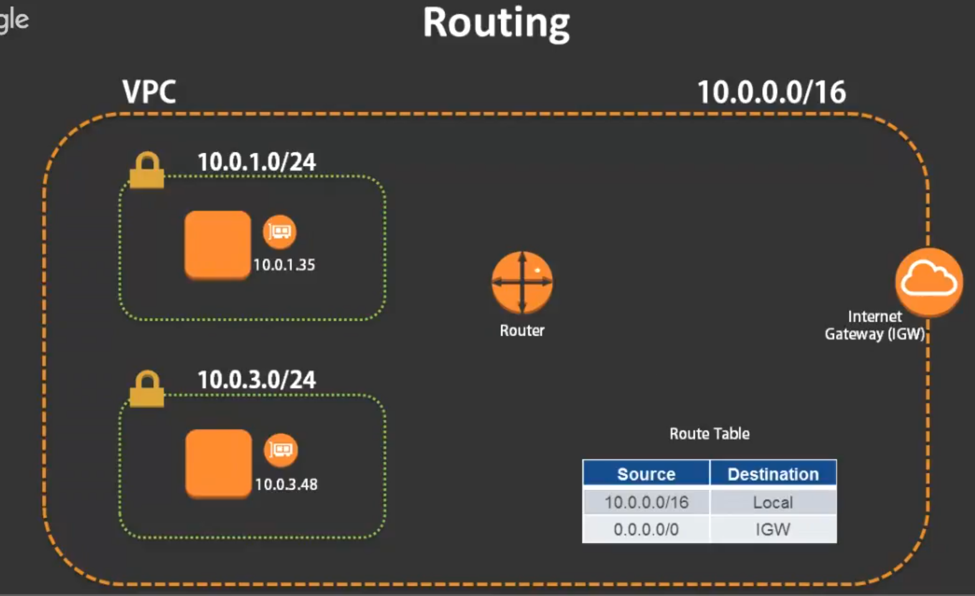

1. let's take a look at how routing works within VPC. So let's bring back the same VPC we have 10.0.0.0.16. 2.We have a subnet here. we have another subnet here we have an ec2 in the first subnet which has an elastic network interface attached to it.It has an IP(10.0.1.35)

3.We have also another instance which has a network interface attached to it with another private IP address.(10.0.3.48)

4. Now we have the Router that sits within the VPC. We have an Internet gateway. And, We have the route table.

Now how this works is pretty simple…

1. when one ec2 wants to communicate with another EC2.. Let this system (10.0.1.35) wants to communicate with 10.0.3.48… here's how it works:

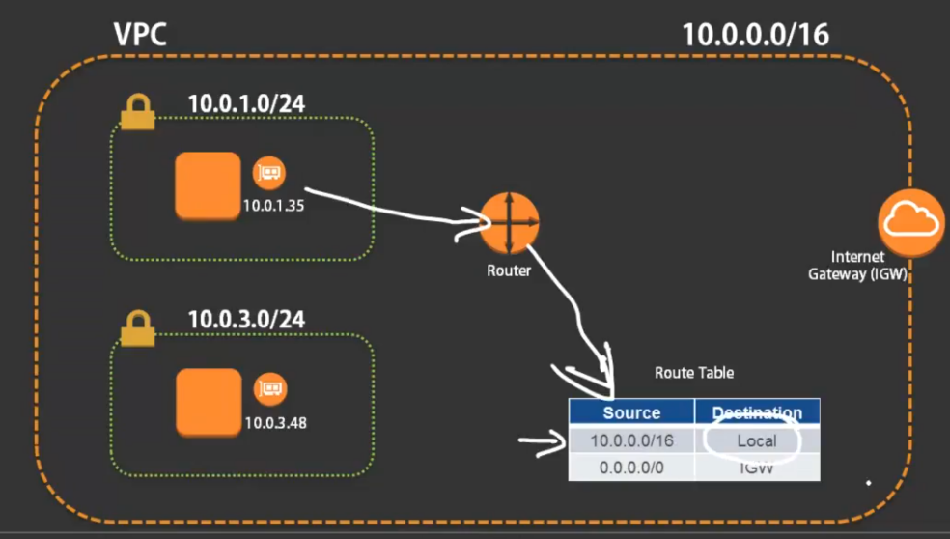

b.) 10.0.1.35 makes a request to the router saying i want to talk to 10.0.3.48, the router will then go to the router table and look at it if there is any routing information in it now.

c.) the first table says 10.0.0.0/16.., the routing is always local which means any system requesting for any IP in this range(10.0.0.0/16----VPC CIDR) the communication is local.

So you can search for the system locally which means you don't need to send it out to the internet.

d.) So when the router has this information it looks up the router table.., it says ok this system which is 10.0.1.35 is requesting for 10 .0.3.48.

Now 10 .0.3.48 is obviously part of 10.0.0.0/16 it is part of the main network.So then the communication happens locally .

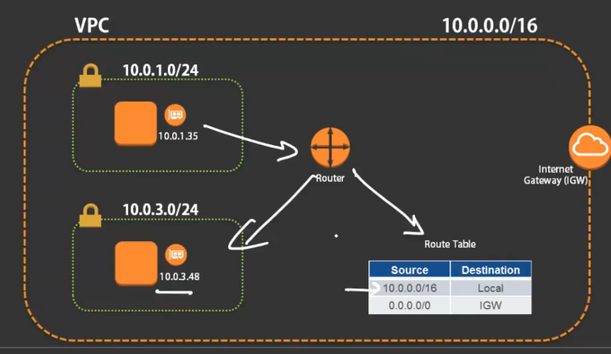

It does not have to go out the router obviously already knows which systems are locally there so it will route it to that particular system.

This is what the router table does.

-----------------------------------------------------------------------------------------------------------

a.)Now let's say this system(10.0.1.35) wants to communicate with let's say an IP address out on the internet and ..say: 53.19.1.4 .

b.)So this system (10.0.1.35) requests to the router talk to 53.9 ..Router goes out and look up the Route table when it looks at the Route table.. It does not match this…

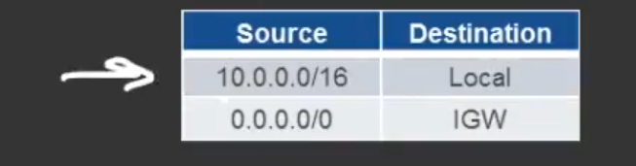

*because obviously 53.99 1.4 is not part of that first one.*

*c.)however* there's another route in the Route table.., which says any IP.

What happens here is: You have an entry in the route table which says every other IP so if there is no match in any of the rules that have already been specified ..,it will go ahead and send it to this range which is any IP.

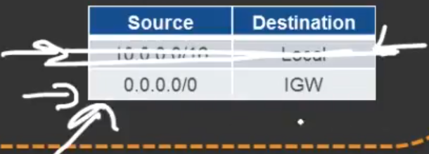

d.)now what is the destination over??? here the destination says Internet gateway .

0.0.0.0/0 is actually any IP and the destination is Internet gateway.

e.) So then the router forwards that information to the internet gateway which then goes out to the internet and connects to that IP.

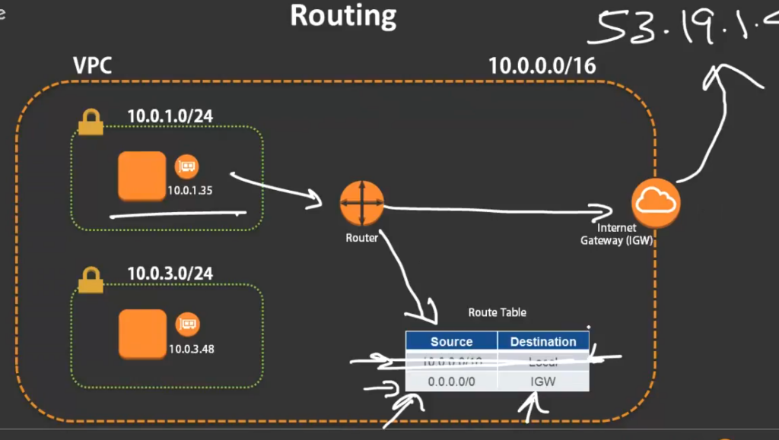

f.)So this is what the route table does… **It has information as to where that information is supposed to be forwarded to.., so that the router can forward it and then it gets carried forward from there…**

g.) Now this 0.0.0.0/0 .. it's basically any IP .If none of the rules in the previous ones match it will go ahead and send it to that IP address.

---------------------------------------------------------------------------------------------------------------------------------------

**how we make public or private:**

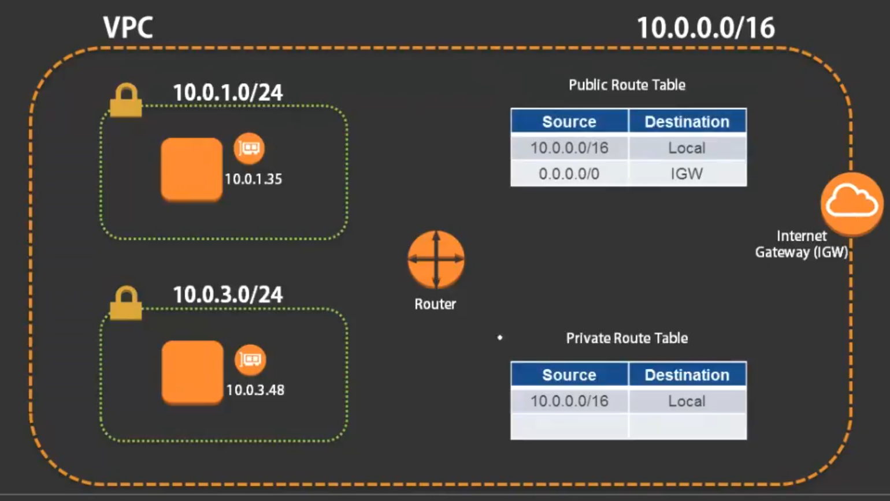

Let say I have two route tables.. I have a **public route table and a private route table.**

-🡪 Now why is this route table called private??? because if you look at this this route table has only one entry which allows local communication.

There is no other entry in this route table to send the information out to the internet which means there is no association of any Internet gateway or there is no association of any NAT gateway as such.

There is only one route and that is local which means anything .ANY query that is coming to this route it will only allow the communication to be private..

🡪 However if you look at the public route table.. Exactly the same one as we have discussed before. It has a public route which sends it to the Internet gateway for any IP that is not local ..**that is any public IP it will send it out to the Internet gateway**.

3.)Now when I go ahead and associate this public route table with subnet 10.0.1.0/24 ,then this subnet becomes public.Before that this subnet is just another subnet.

**when I associate that route table with that subnet it becomes a public subnet** and

when I associate the private route table with this subnet(10.0.3.0/24) it becomes a private subnet.

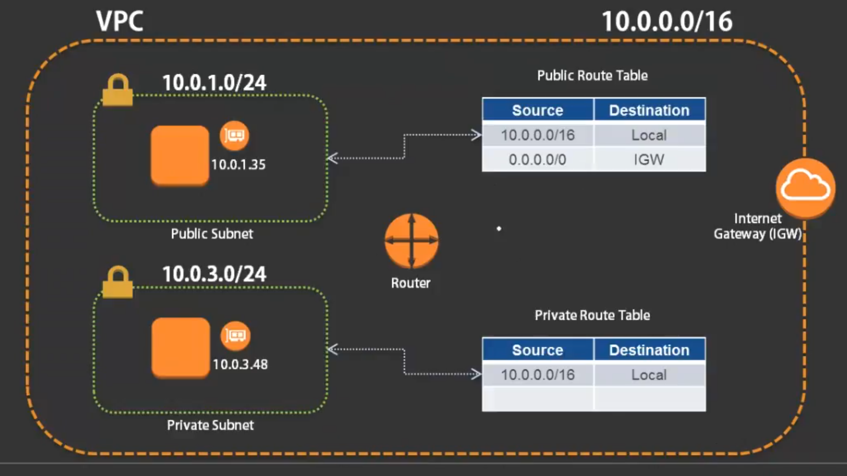

4.)Now let's look at what happens with the private subnet..

a.) let's say this private subnet system (10.0.3.48) wants to communicate with ten 10.0.1.35.

So the request goes out to the router the router checks the router table associated with that subnet.That subnet has a particular route table Associated with it.. The router checks for that it and if it is part of this 10.0.0.0/16. I will send the communication local then the communication will be sent locally.

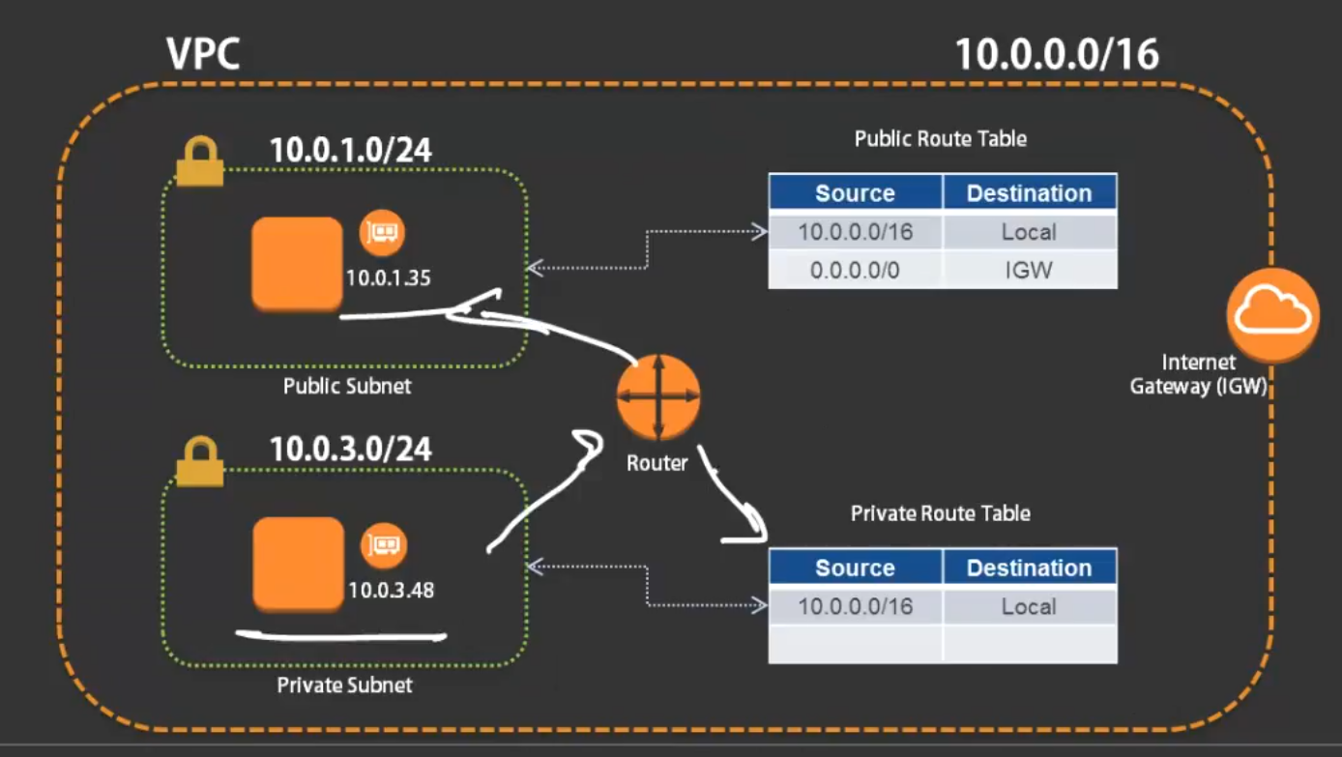 b.)however let's say this system (10.0.3.48) is now trying to request for an IP that is outside 52.99 1.4.

let's say it's trying to reach that IP address.

So it sends the information of the router. The router comes and looks up at the router table. It does not see any route for that IP that communication will be denied. There is no outside Internet access.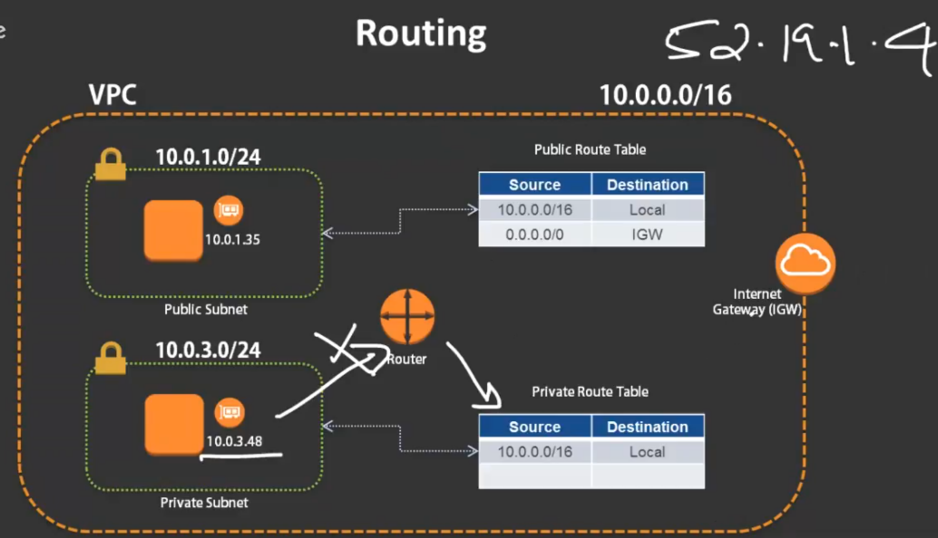

**Same way there is no internal access as well the Internet gateway cannot send anything to this system because there is no return route.**

So this is essentially a private subnet.

So any systems in this subnet ..,can communicate with other subnets in any other availability zone as long as it is part of the local routing.

However they cannot communicate externally because there is no external access.

5.) If this system (10.0.1.35) wants to talk to the internet.., there is another route here. It will go out to the Internet gateway and then it can go out and then come back.

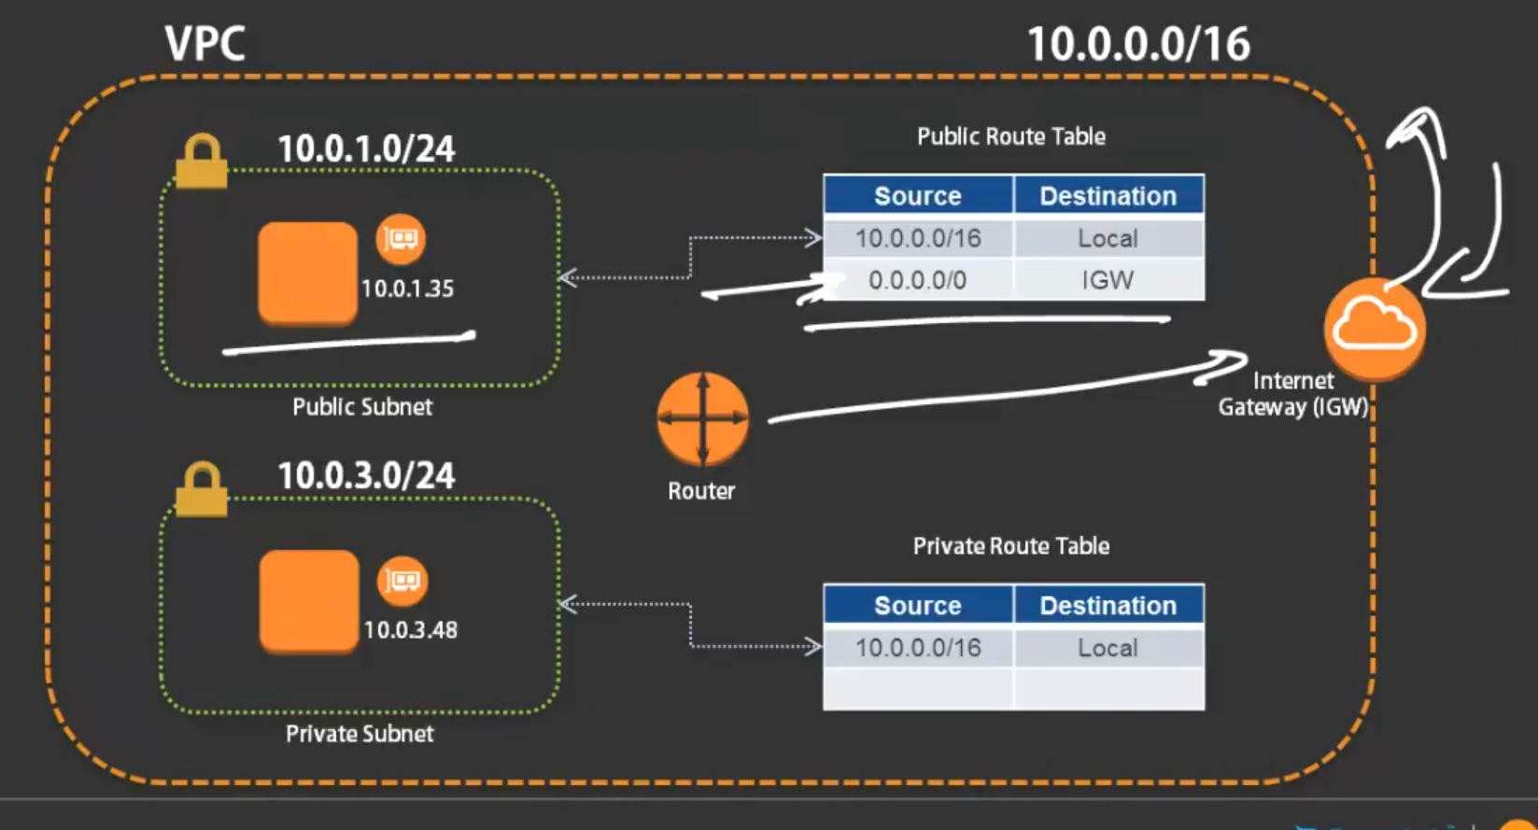

so I hope this concept of routing is clear guys I'll take a moment here I'll pause and I'll ask if you have any

***NOTE:*** *route table is the one* that decides whether a subnet is a public subnet or a private subnet. By default a subnet is neither public or private… it gets associated with a default route table.

2.) within the VPC by default there is always a local route specified. So all the subnets within a VPC can communicate with each other regardless of what table they are associated with.. because every single router table has a default local route.

3.)it's only when you want to decide whether you want to send it out or not that you have to specify an additional rule in the router table which will actually send it out to the internet way.

***Questions****:*Does request from private subnet to router only check private route table??

It depends which route table is associated with the subnet.

So if there is any system inside this subnet,it is obviously going to check with the route table that is associated with that subnet.

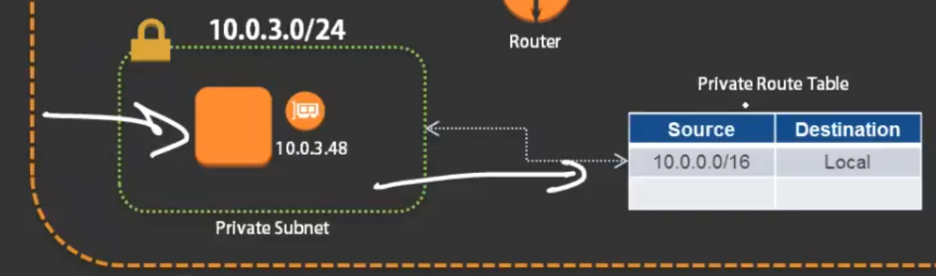

If there is any system inside this subnet it is always going to check the route table that is associated with that subnet .

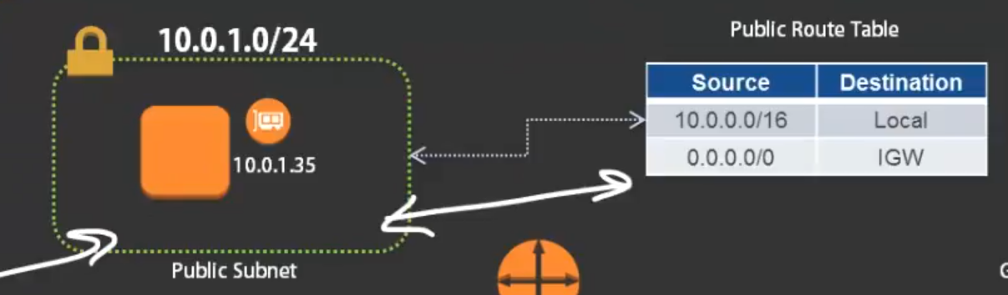

So you have to associate a route table with a particular subnet and it will always check the route table for that subnet ..whether any systems in that subnet can talk to the outside world or not …

**NOTE: 1.)**Remember that you o**bviously apart from the routing a route table if you need to make public communication you obviously need a public IP address**.

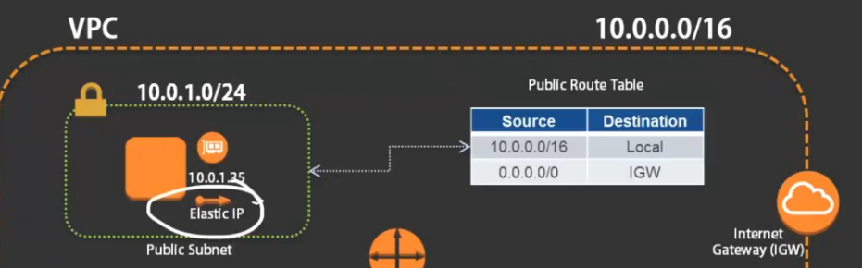

So apart from associating your route tables.., your ec2 instance should also have a public IP associated with it either a dynamically allocated IP or an elastic IP associated with it .

b.) However for information to come back in you obviously need a public IP otherwise that system is not going to be able to communicate with the Internet.

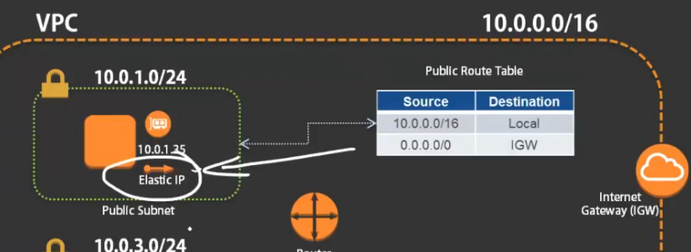

2.)but remember even if this system in the private subnet has an elastic IP it's still not going to be able to communicate because of the fact that the route table does not have that information.

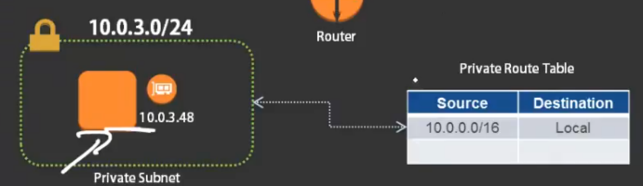

**Que:** the role of DHCP within AWS ???it's actually assigned automatically.. There's something called DHCP options

3.)So, There is always a default route table that is available inside whenever you create VPC. The default route table it's always local.It’s always private right. There is no public route that is there by default.., unless you create an Internet gateway and then you connect then you create an entry in your route table which goes to the Internet gateway until and unless you do that till that point essentially your subnets are private…

**NAT gateways**

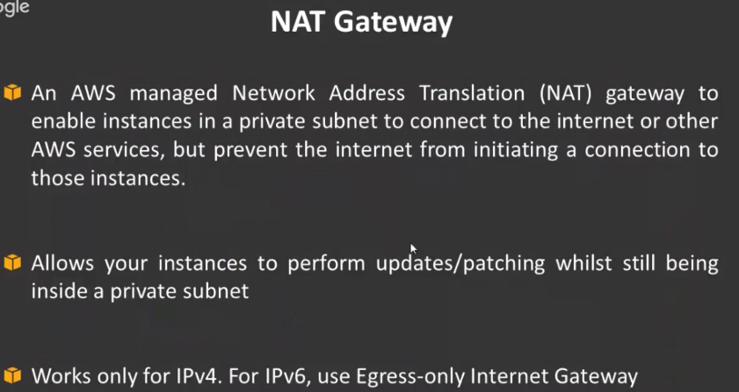

1.)A system inside a private subnet if it wants to communicate with the outside world.A NAT gateway is basically a managed service that AWS provides you which allows you to make a communication or a connection out to the internet but it will not allow any new communication to be initiated back into the subnet..**Unless it was actually requested by the system in that subnet it's not going to allow any communication to come in.**

2.)This will allow your instances to actually do any kind of patching or updates or anything that it needs to do this works.

3.)NAT gateway works only for ipv4.. If you want to do **ipv6 same way there is something called egress internet gateway..**

**So let's look at how NAT gateway works:**

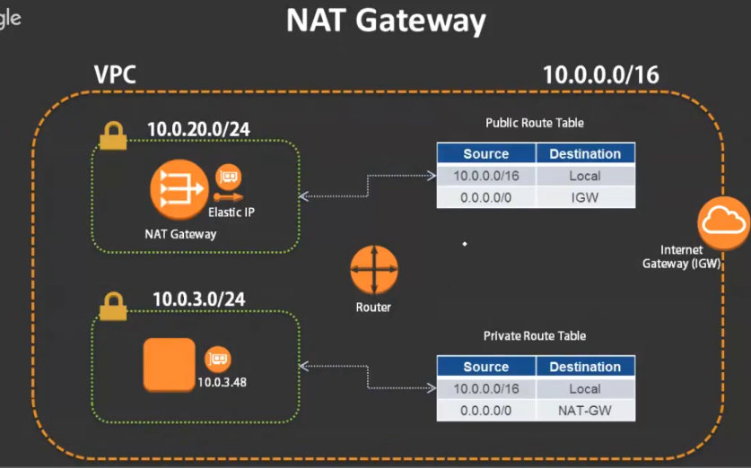

a.)Here the similar configuration here guys except that the public route table and the private route table here…, is that in the in the public subnet ..,instead of your regular instance you have something called an NAT gateway

b.) if you look at the private route table ..,there's a new route here which is actually out to the internet.

first you have to create an NAT gateway and then once the NAT gateway is created you have to update that information in the route table.., so that it can start routing to the that gateway.

**let's see how this routing works now**.

1. let's say there is an IP address of 52.99 1.4 and let's say this system(10.0.3.48) in this private subnet wants to now communicate with this IP address outside on the internet…, which is it's a patch server and it needs to contact the patch server.
2. Now this request goes out to the router ..The router looks up the route table and it sees an entry for any IP or any public IP and the destination is nat gateway (it's not the Internet gateway ).
3. Then this request gets forwarded to the NAT gateway.
4. Now the NAT gateway already knows what to do because **NAT Gateway is a managed service you don't need to configure anything as such.**
5. This NAT gateway will now forward that communication out to the Internet.
6. **Now obviously when it sends it to the router,** the router looks at the route table then it forwards it to the internet gateway.

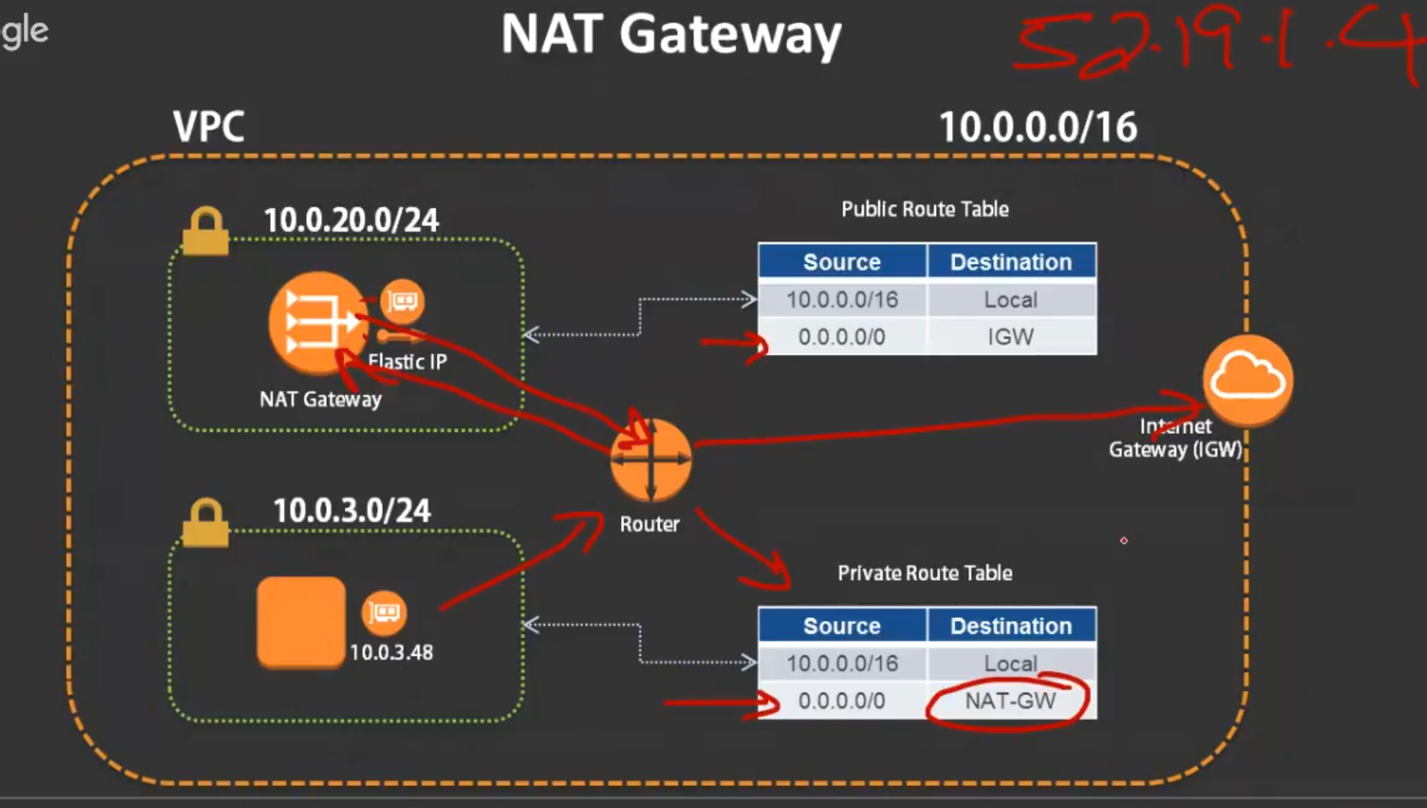

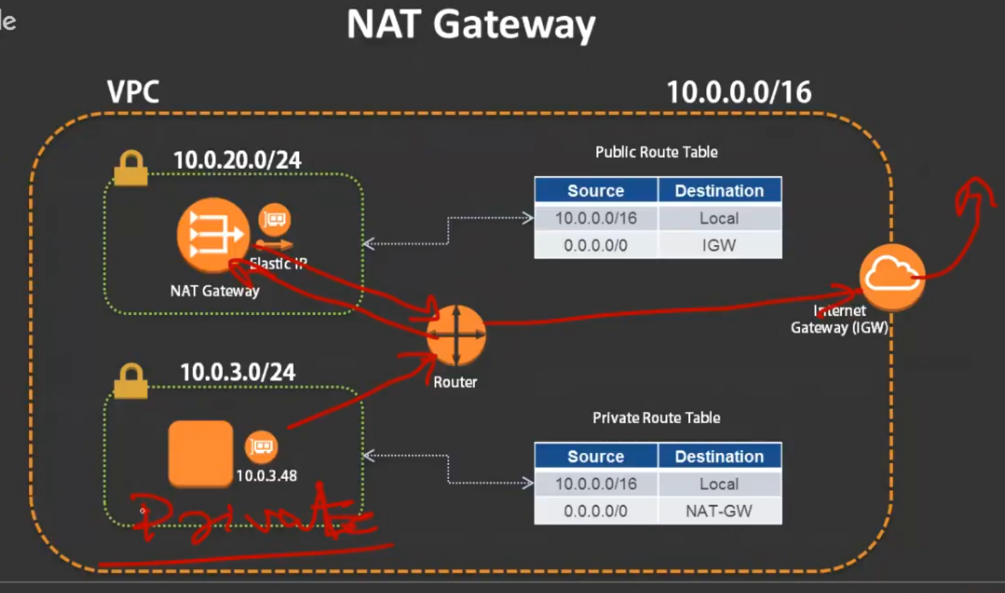

1. This is how the NAT gateway works for systems inside your private subnet.

So if you have any systems inside your private subnet that wants to access the internet this is how you set up the nat gateway .

**Questions**: **What is a bastion host or jump host**

For example: let's say the same case where you want to connect from outside. You want to login SSH into this system(10.0.348).

Obviously you don't have a public route and you can't do that even if you have an NAT gateway. You can't initialize the communication inside unless the system had requested it.

So what you basically do is you actually put an ec2 inside your public subnet… You SSH into that and then from that system… you SSH into the system(10.0.3.48)…

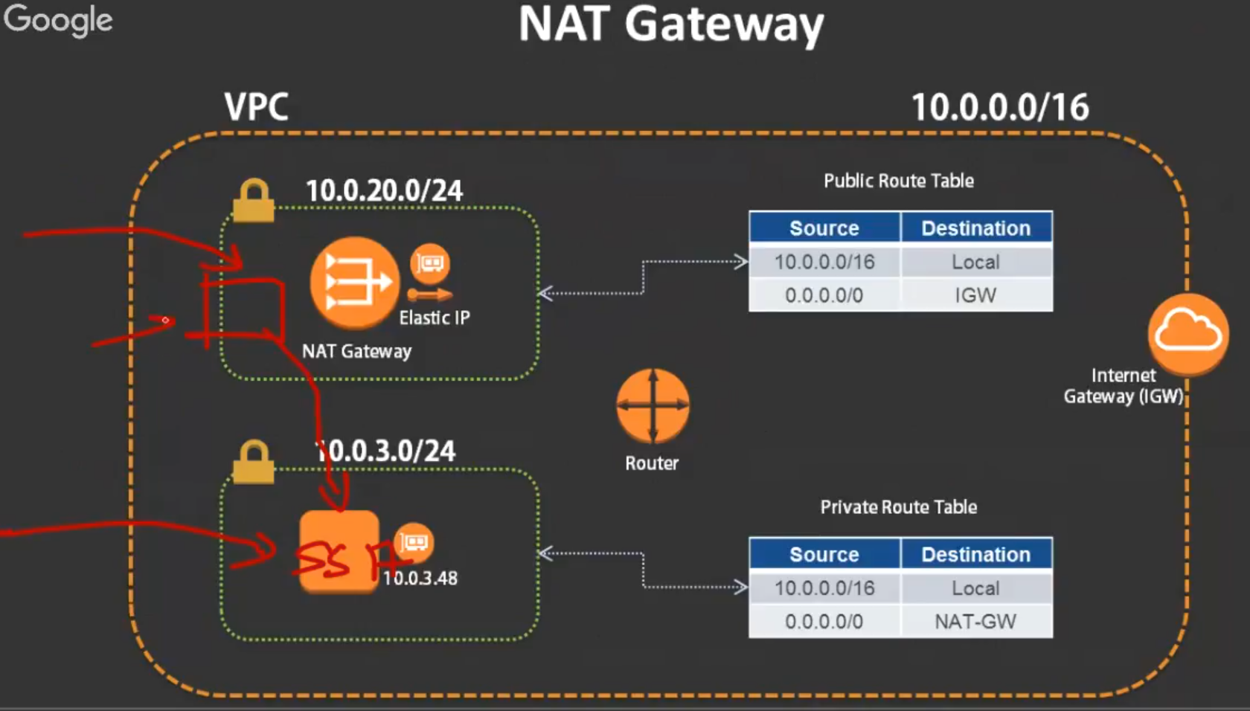 This is basically a jump host or a bastion host. So it's just two entry - routing table to create that gateway.

**Key points:**

* Subnets can be private or public and are limited to a single availability zone. So remember your subnet is always inside and availability zone.
* subnets must be associated with a route table. Without a router table wont be able to out any information anywhere.
* An Internet gateway route must be added in the router table for internet access inbound and outbound so without internet gateway there's no way you can communicate with the internet unless of course you are using a NAT gateway.

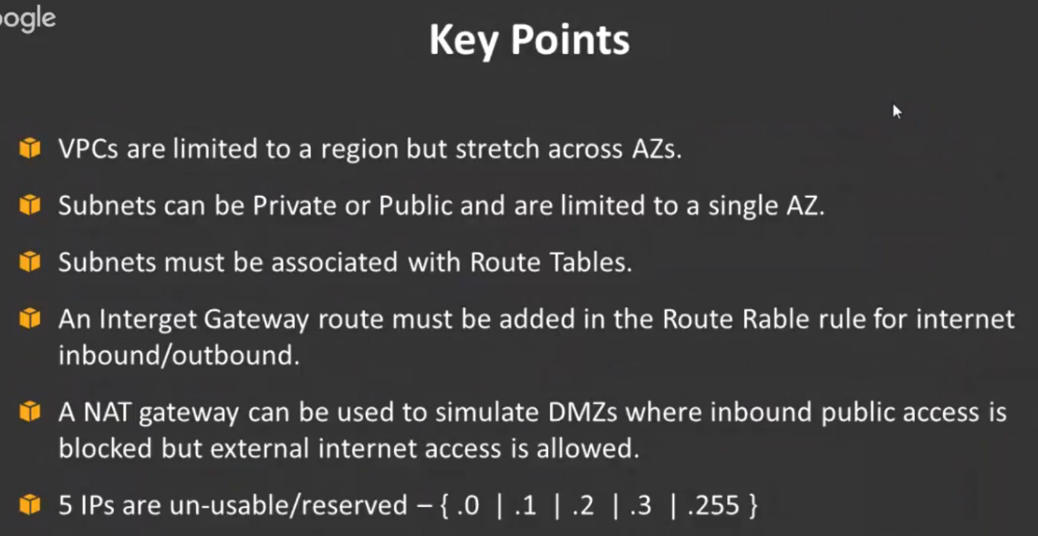

* An NAT gateway can be used to simulate the dmz zones which is allow we're inbound public access is blocked but external access is allowed.
* 5 IPs are reserved. So five of them are not usable when you create your Vpc.

**NAT gateway:** it's a managed service. It is not an ec2 instance which means you're paying for it as a service.

you don't need to configure anything like you don't need to log into the NAT gateway to configure any kind of routing or anything like that.

However before the NAT gateway was introduced what people used to do is they used to have an ec2 instance.. Which had the same functionality of what NAT gateway does …

But you had to configure that on the software level. So you **on the software level you will configure all the routing which is like you have to disable something called source source port source destination check.**

**…>**you disable those things and you can actually do additional things like IP filtering intrusion prevention detection all of those kind of things additionally on an ec2.

but you have to manage this ec2 you have to configure it you have to update update and patch it you have to look up all the rules everything has to be managed by you so instead of that what they started offering is without you having the headache of running an ec2 they provide you a managed service as the NAT gateway where you just put it in the route table it'll handle all the requests for you.

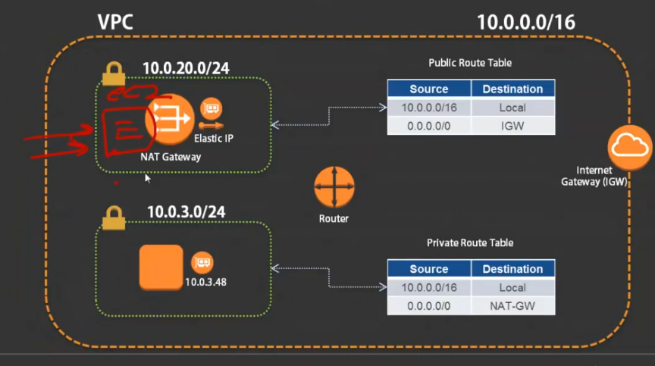

**NAT gateway is used whenever you do not want inbound access to your systems but you want to allow outbound access.Technically speaking that is a private subnet because the public subnet by default.**

has public access inbound right…

So it there's no point in having an NAT gateway in a public subnet.

**VPC endpoints:**

a.)Some of the services that are available like Amazon s3 or even dynamodb. Although they are on AWS when your ec2 instances are talking to them they actually have to go out through the internet gateway and then come into s3 using the public endpoint.

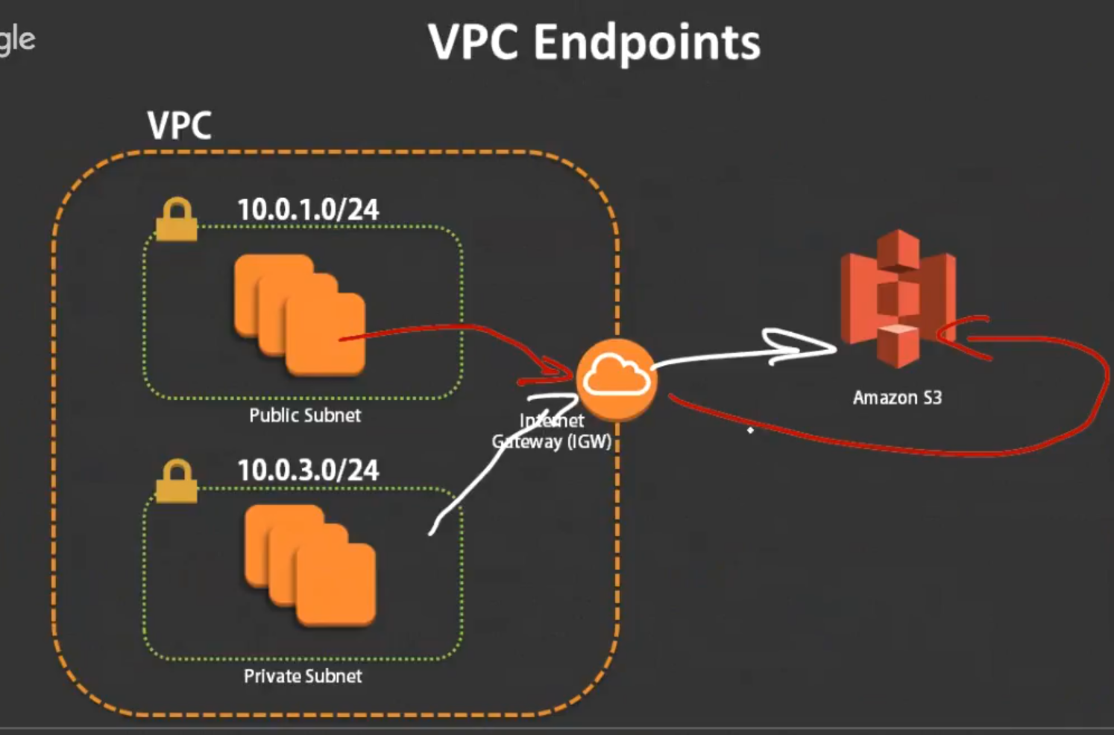

b.)So this is what I mentioned before that it's not necessarily a good option because you are traversing the public Internet although you know you're still using HTTPS and you're securing your connection and all of that however it's still traversing the public Internet and you don't want that happening if you want to actually transfer data that is highly secure.

**So anything that you're trying to communicate with normally with s3 it goes out to the Internet gateway and then goes to Amazon s3.**

c.)But what VPC endpoints do is it creates something like an Internet gateway.

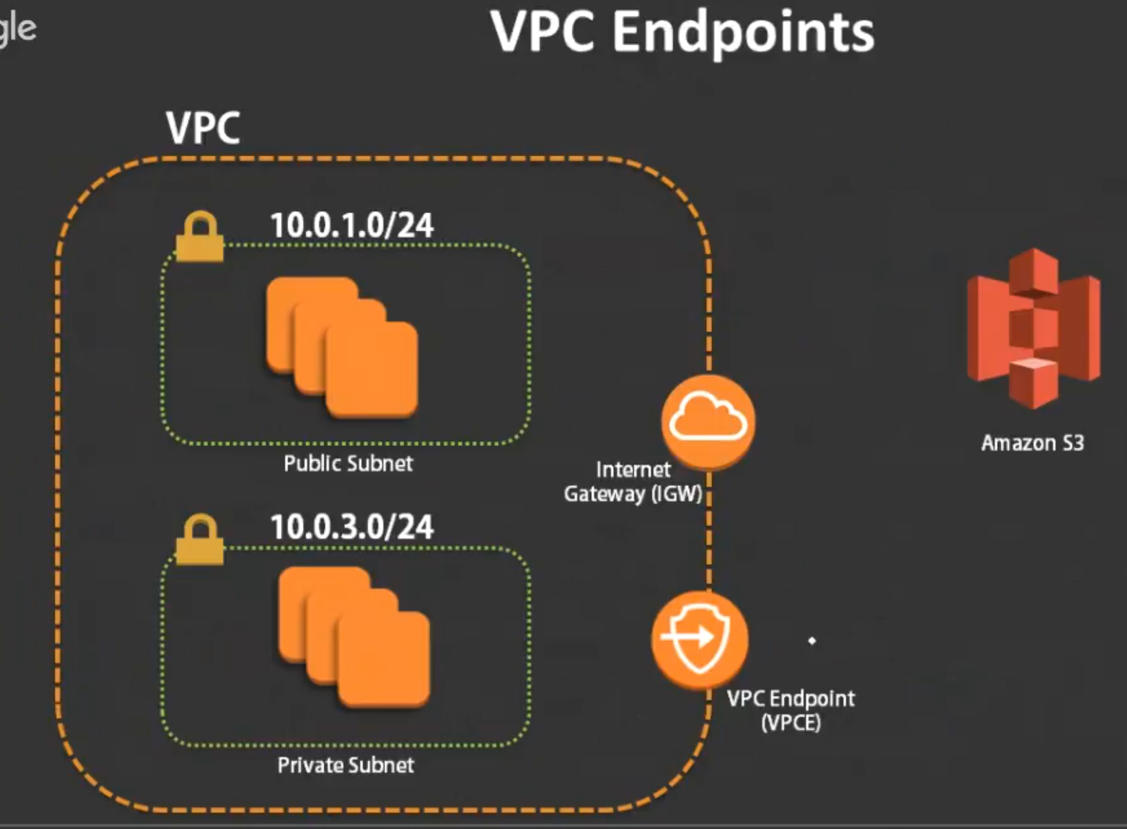

It is a gateway..So to speak it's an endpoint all your instances will now talk to the endpoint and then through the endpoint it'll connect to s3.

d.)The difference here is that this communication is in the private network within the AWS private network.

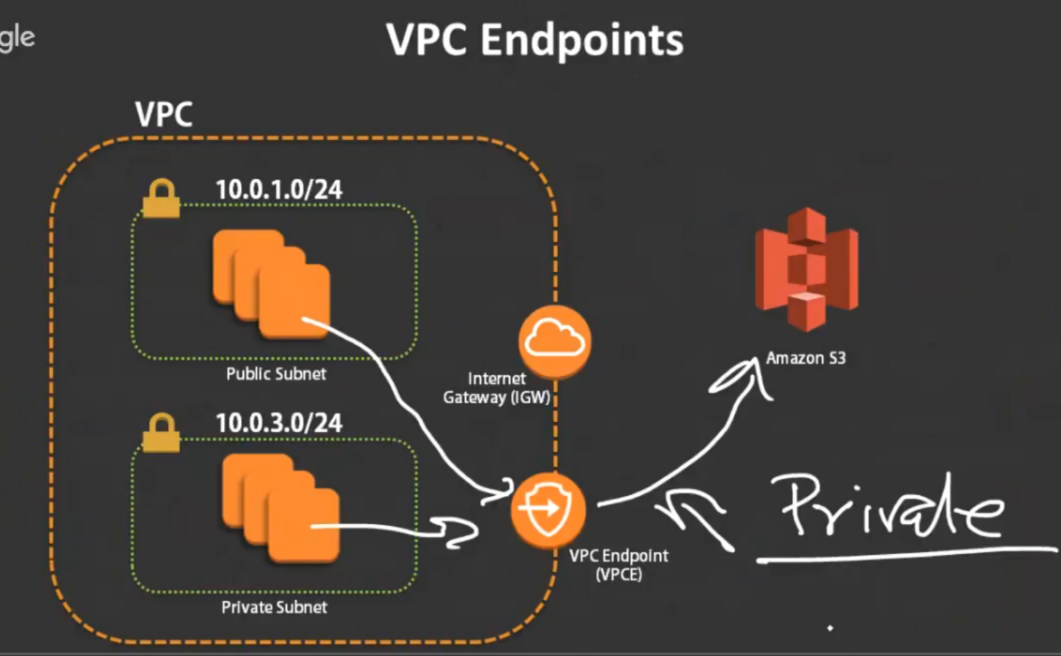

It is not going out to the public Internet. So the communication that you have here is much much more secure than what you generally get when you're trying to use a Internet gateway to communicate to be services.

e.) As of now you can use VPC endpoints with Amazon s3 as well as dynamodb.

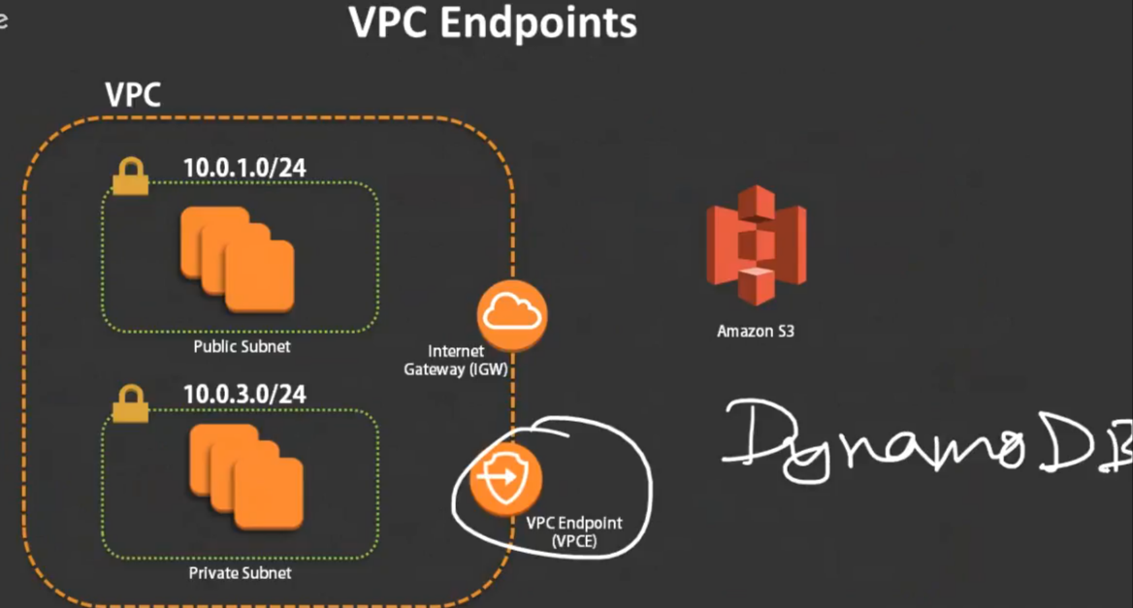

4.) There are some other services… However which uses something called endpoints but it is a little bit different it's known **as interface endpoints**.

So the services are things like when you're using the API calls for your ec2 when you're using the Service Catalog application, or when you're using elastic load balancers ,when you're using the ec2 Systems Manager , Kinesis streams, Cloud watch logs, encryption for kms and the SNS notification system.

1. Same thing happens before .., when you used to communicate .This has to go out to the Internet gateway then it talks to all of these services individually… It's going over the public internet.

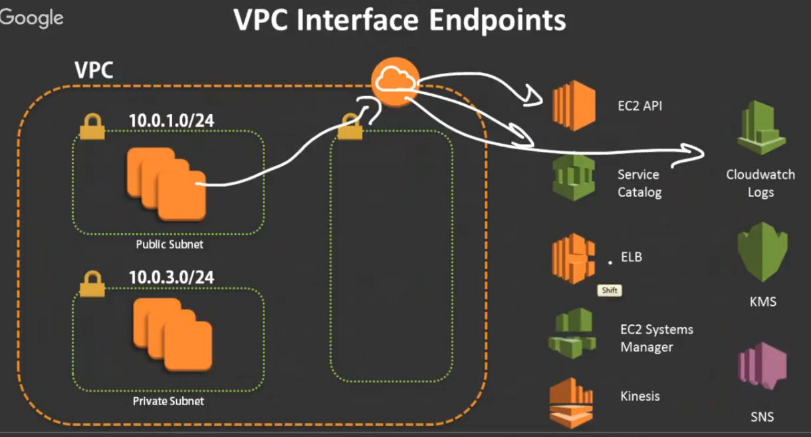

b.) However now with the option of something called interface endpoints.

What happens is??? there is an ENI that is actually created for each of these services and then that is mapped to that ENI.. So now your ENI has a private IP address like 10.0.15. 10 .

Each of these ENI’s have an IP address the local IP address that is associated with them.

So now when your communication happens it is private here and obviously this is also private because it's not going out to the internet.

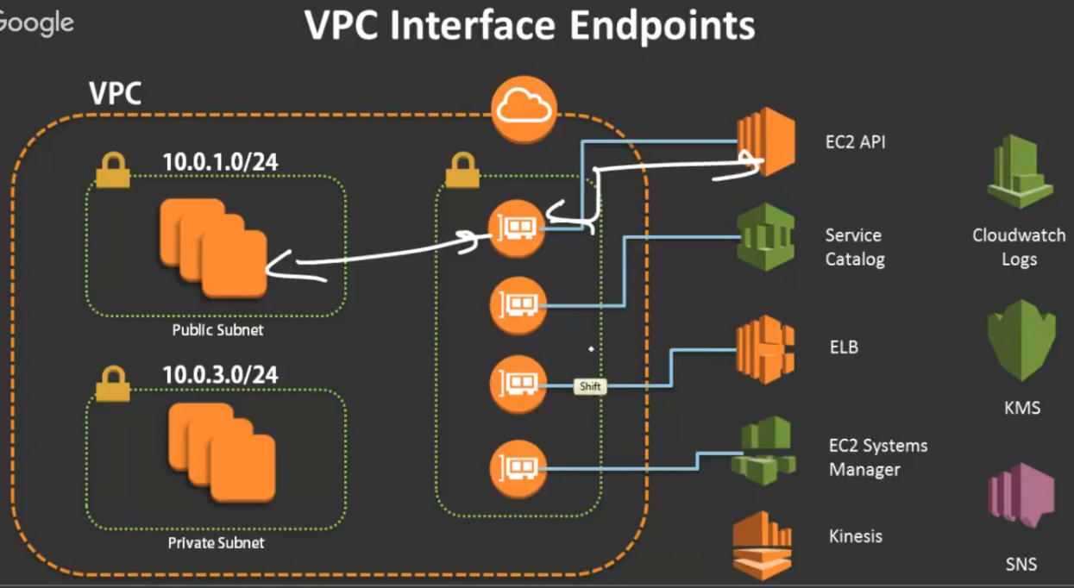

**These are the two things between endpoints and interface endpoints.**

**End points basically you just have a gateway and it goes out to the gateway.**

**in interface endpoints: there are the other external services where it creates certain elastic network interfaces within the subnet all right and then all of them are mapped here and when you communicate with those endpoints it is actually going to go out through those ENIs and it's not going to go out through the Internet gateway.**

I just want to quickly show you a slide that was recently there in the reinvent session by Amazon back in 27 20 17.

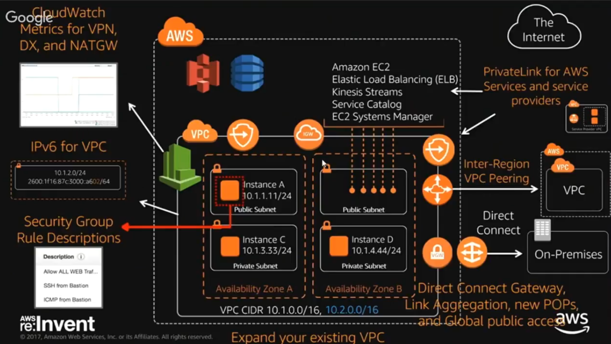

If you look at this these are the new features that are available on the AWS VPC as of today.

* They introduced ipv6.
* There is something called security group rule descriptions..
* There is support for cloud watch metrics now for all VPN Direct Connect and NAT Gateway
* All the private link services which I kind of already mentioned the ENI’s which are created for all of these services.. ENIs gets created in each of the subnet.
* VPC endpoints which connect to s3 and DynamoDB.
* They introduced inter-region VPC peering, which means you can now connect multiple VPCs together. even if they are across a region.
* Direct Connect and connect gateway and
* **expanding your VPC..** so this was recently introduced feature.as such like I mentioned if you already specified a CIDR range you can expand your VPC by specifying another side range.

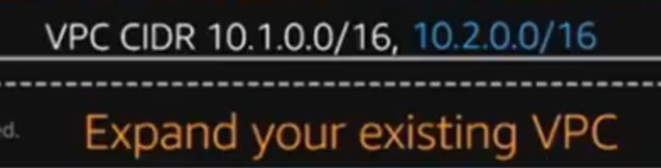

So you don't have to be stuck with you know a single CIDR range that you happen to specify initially.

Before this was a very large problem before because some sometimes you had ended up creating an vpc which was pretty small and then you realize that you run into these issue constraints of not having enough IP addresses…

**Questions:**

yes for CloudWatch ,we have an enI available. So when you're sending and receiving logs from cloud watch now you can securely send it through ENI that you connect via the interface endpoints.

You don't have to talk to the cloud watch as a public service.



We have VPC wizard in order to create a VPC..However that's too easy and you might not understand what's happening behind the creation of the VPC.

So we'll go to your VPCs over here.

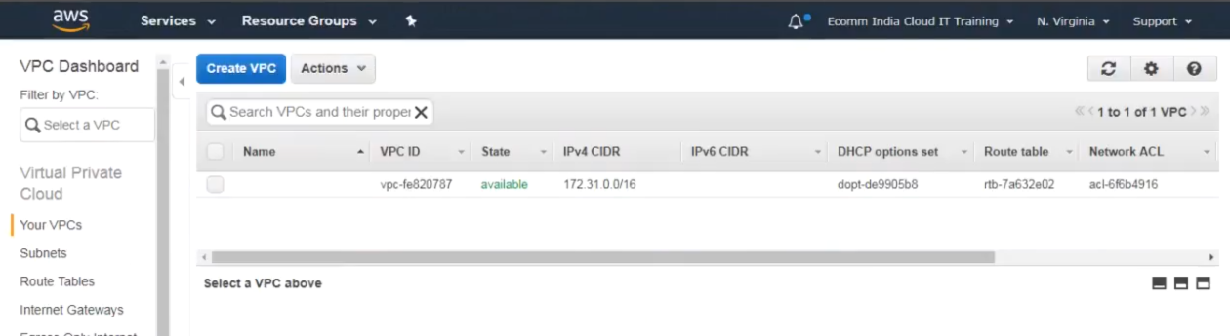

0.) I've already mentioned: **you always have a default VPC that is available in your account in every single region**

Now, I'm in the North Virginia region and as you can see there's already a default VPC available there even if I switch regions there will always be a default VPC and almost all the time they're going to be a 172.31 range.

1.)hit create VPC.

first thing it's asking me is for a name and CIDR block.

Name: webinaar and CIDR🡪10.0.0.0/16

🡪If you want you can assign ipv6 assigning it right now I'm not going to show you the ipv6 right now because it's that that's another subject altogether I will discuss that in the part two but when you do this you are going to basically allow ipv6 .So if you want to switch this on you can just put it to Amazon provided ipv6.

🡪Now again this is the ipv6 address that AWS gives you. So you don't get your own IP address this is basically a / 56 ipv6 block.

You have a /56 ipv6 block for your VPC and then you do /64 for your subnets.

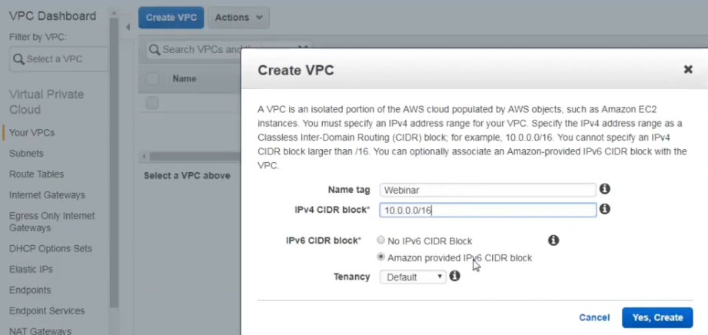

2.)create subnets.

Create one public and one private subnet in two availability zones ..Total of four subnets ..2 public and 2 private.

In which one subnet will have one public and one private.

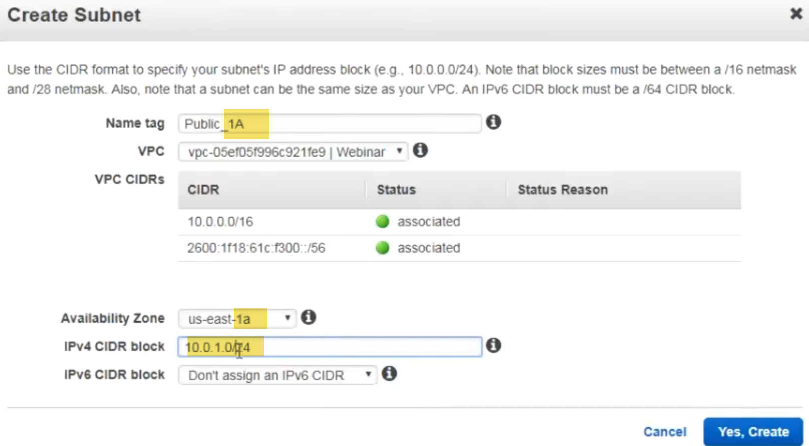

**When I create these subnets they're actually not automatically becoming public or private unless I'm assigning them to a route table .**

I'm going to create three more and I'm going to call this private.

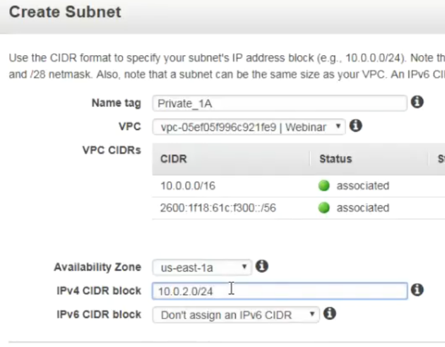 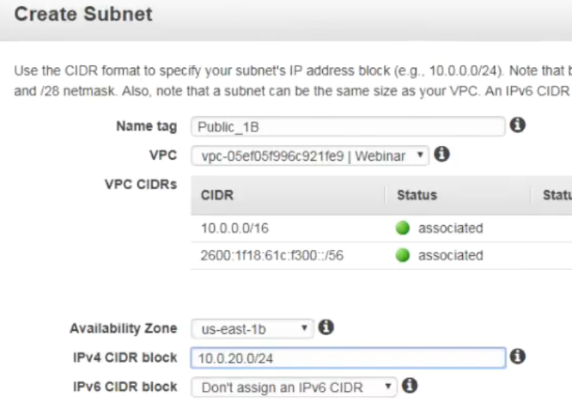

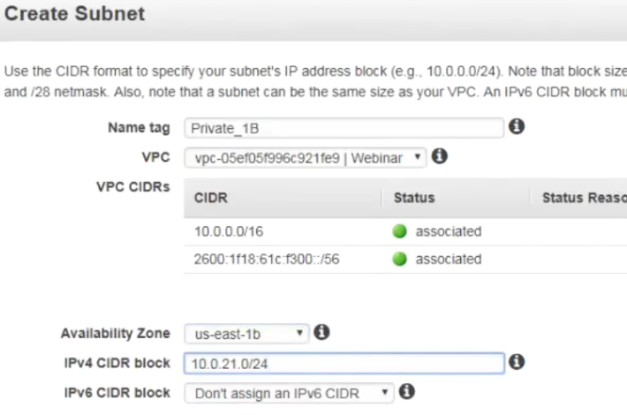

Now I have the four subnets that I require now …just to filter out this view I'll just go ahead and type in webinar over here so that it shows me only the subnets that are associated with my VPC..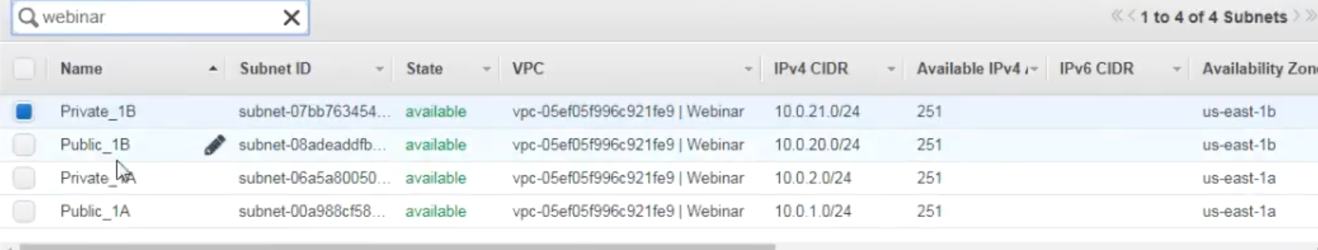

I have created four subnets private1 b, public1b, private1a and public1a.

**You can see what are the different side ranges on it and as you can see it shows 251 IPS available because remember 5 IPS are not usable in each of the subnets out of 256 if you take out five that essentially becomes 251**.

3.)Now, I need to create an Internet gateway because before I assign anything to the route tables I need to create an Internet gateway.

a.)If I go into my router table and if I see the route table that is associated with my VPC.

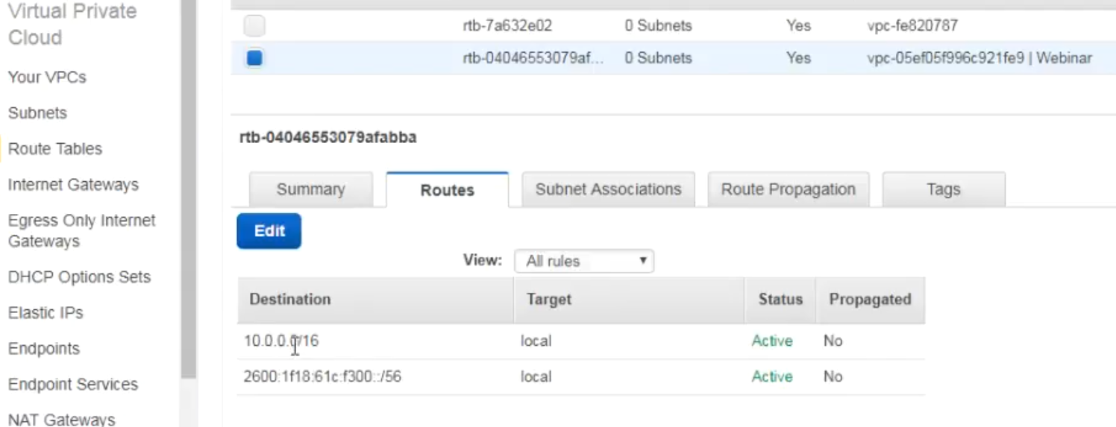

you can see there is two routes one is ipv6 and one is ipv4.

As you can see in ipv4, there is this single route for local… there is no external route.

**And it says that it is the main route table. So remember this is kind of the default route table so if I create any subnets that will automatically use the default route table unless that subnet is associated to a particular route table.**

I'm going to create an Internet gateway.

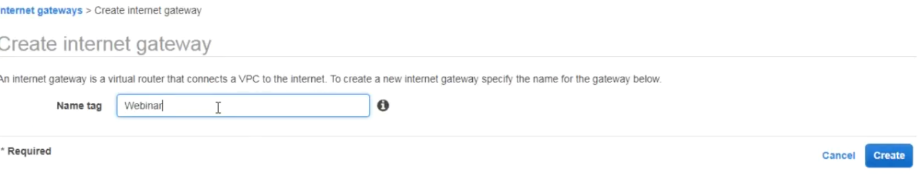

Once you create an Internet gateway, you need to attach it to your V PC because you already have another Internet gateway that is attached to the other VPC..

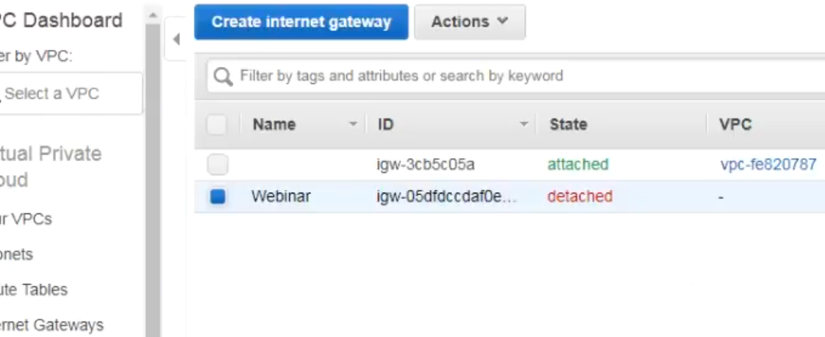

Otherwise my VPC will not be able to communicate outside .I need to attach it to my internet gateway to my VPC.

4.) let me go back to my route tables now

a.) I don't want to use this default route table right I want to create separate route tables for public and private so I will create a router table..

b.)

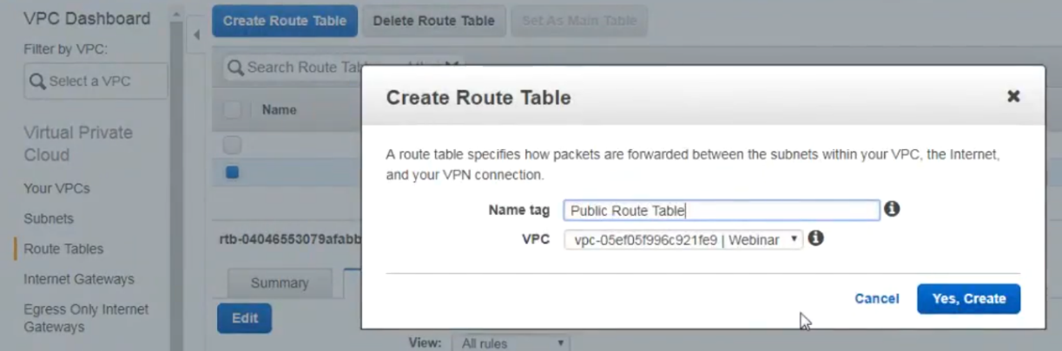

I will call this public RouteTable.. and I'm going to associate that with my VPC and

I'm going to the RouteTable..

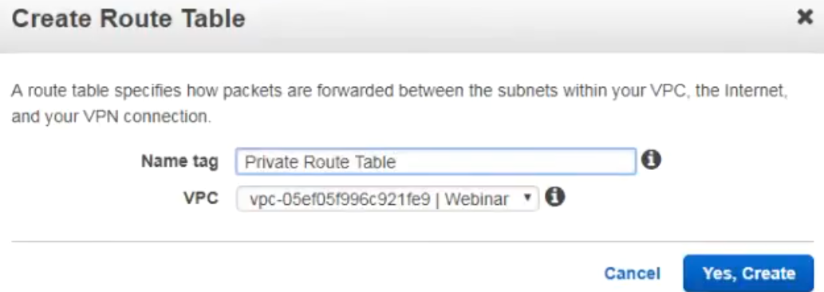

I have created two more additional round tables.. **At this moment there is no subnets that are associated with these round tables..((as shown in diagram)..**

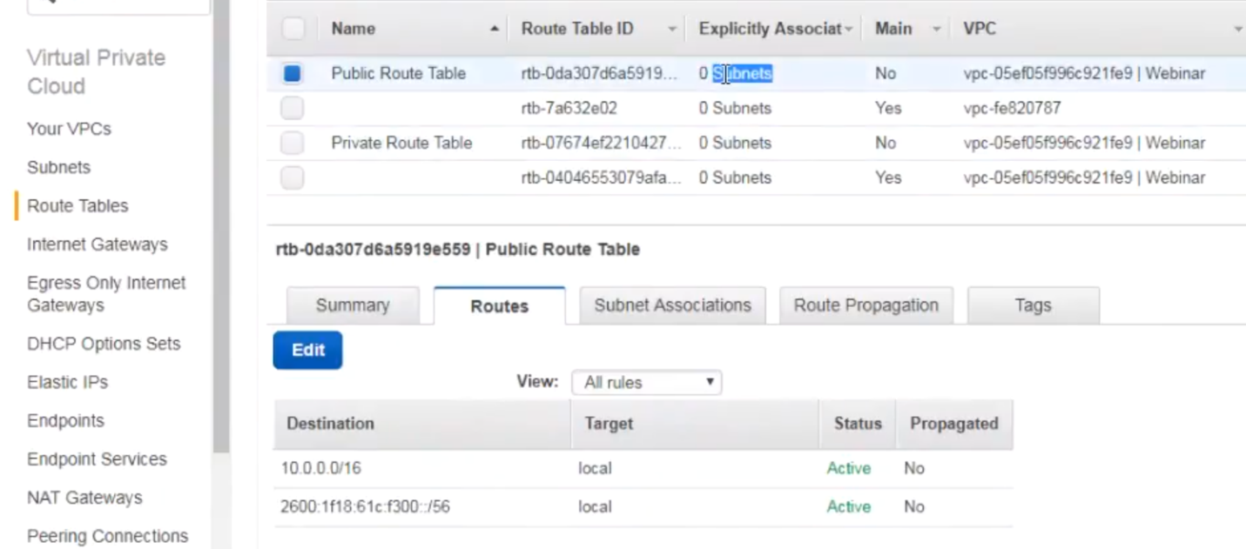

**If I go to private route, it is only local communication.. if I go to the public route ,it is only the local communication… because by default when you create a route table it's local it doesn't assign any outgoing paths now…**

I have 2 private subnets and 2 public subnets in different availability zones now. I have created 2 route tables. I have created a public route table and a private route table..

But as you saw there in the public route table I still have not configured the Internet gateway. I will go ahead and add the Internet gateway route.

So I go to my public route I'll go to the routes tab, I will edit the routes tab and I have an option to add a route here… so I'll click on add another route and route is going to be 0.0.0.0 (every other IP) so this is 0.0 0.0 / and where should I be sending these???

I should be specifying the Internet gateway…

Because I have already created the Internet gateway and because I have already associated it with my V PC as soon as I click on this box I get the option here for the internet gateway …which is igw.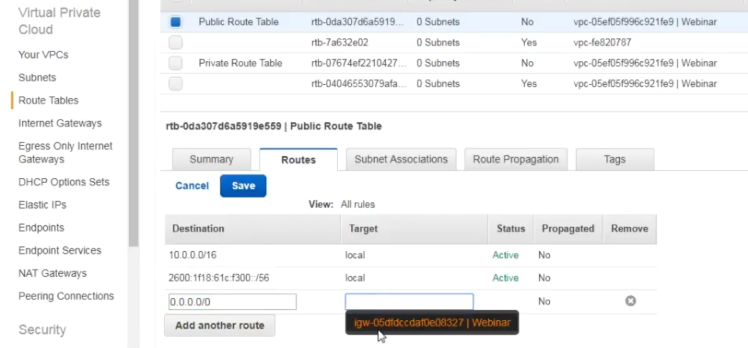

**If you did not already attached your internet gateway to your VPC you will not get this option and obviously you cannot add this**

The difference between my public route table and my private route table is that in my public route table I have a route that goes out to the public Internet via the Internet gateway.

However in my private route table I have no such route it is only going to do local communication.

b.)Now I'm going to associate these subnets with this route table **because as of now all the subnets are going to the default route table** so I will go to subnet associations…

I am editing my private route table so I'll go to subnet associations I will edit this and I will go ahead and select the ones that say private

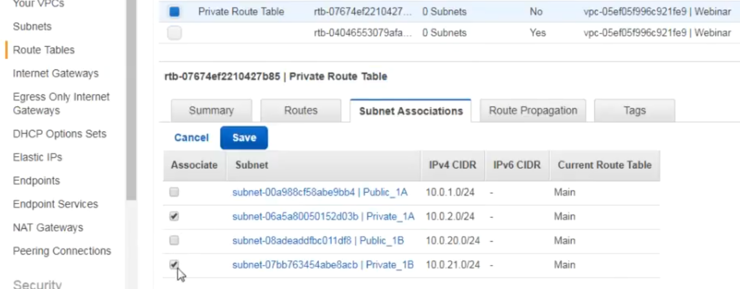

What I'm doing is…I am associating my subnets with my route table. I'm making that connection now .Now these two subnets that I just selected have actually become a private subnet these two subnets which is private one a and private one B are now private subnets because I have associated them with a route table that only has local routing it does not send anything out to the Internet

I will do the same thing with a public route table I will go to the subnet associations I will edit it and I will add the public route tables over here..

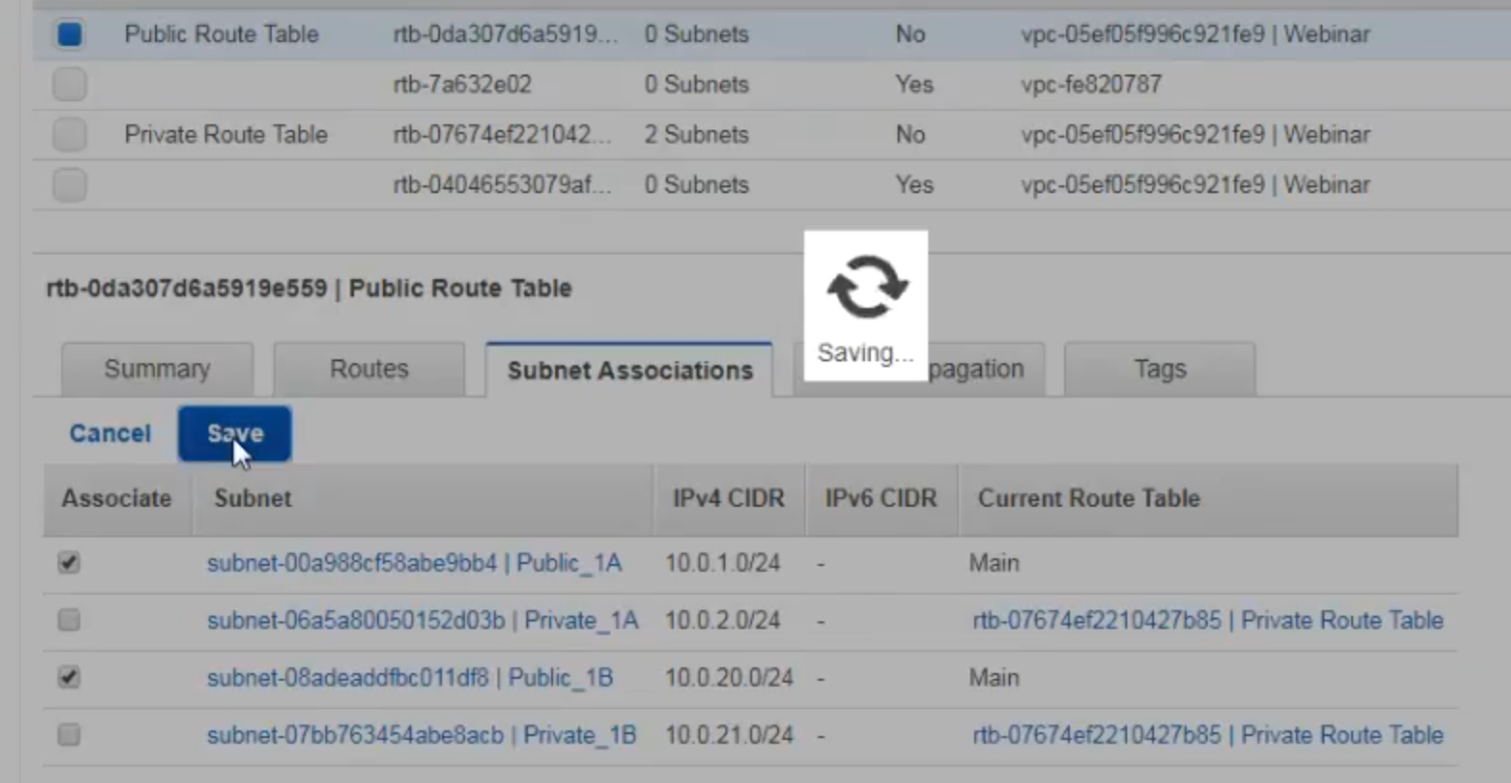

So I will save that so.Now I have made public 1a and public1 be as public subnets because I have associated those two subnets with my route table..

how my sub subnets get differentiated as public or private subnet till that point it is a **default subnet which is again only private now.**

🡪go to my subnets here now whatever I put in public1B and public1a

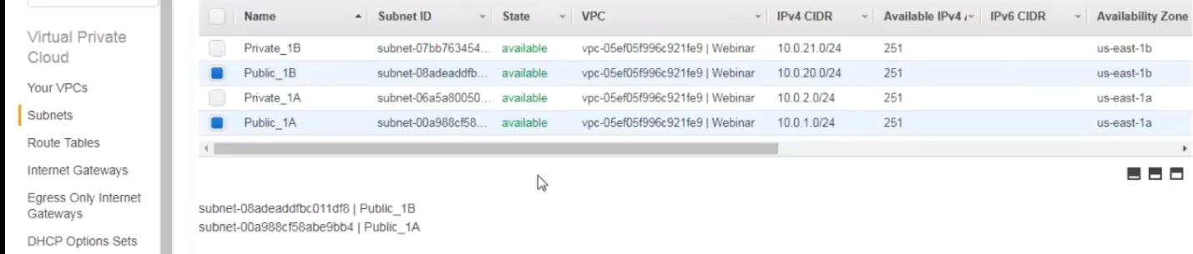

Those systems should be able to communicate to the Internet but whatever I put in private1a and private1b.. will not be able to connect to the internet now.

5.) launch some instances

**route propagation** is used when you are using something when you're using BGP protocols where essentially this route is getting propagated to every other router in the network right that is talking to this particular VPC.

**so at the moment we don't have this V PC connected to any other network so obviously there's not going to be any route propagation and we are not using BGP so that's not going to happen**

One thing I forgot to do before I do that: when you create your Vpcs by default it does not actually do DNS host names resolution. As you see here for my VPC ,it says DNS host names is no… which means I cannot use any any particular host names for my systems within that VPC. it's not going to work

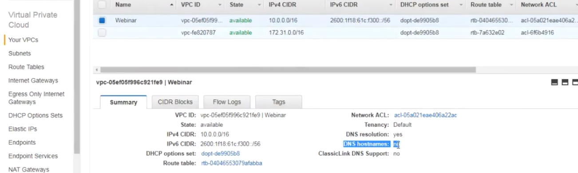

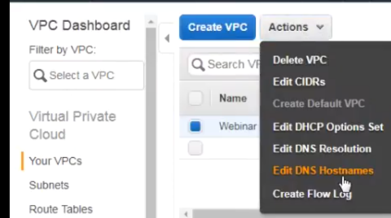 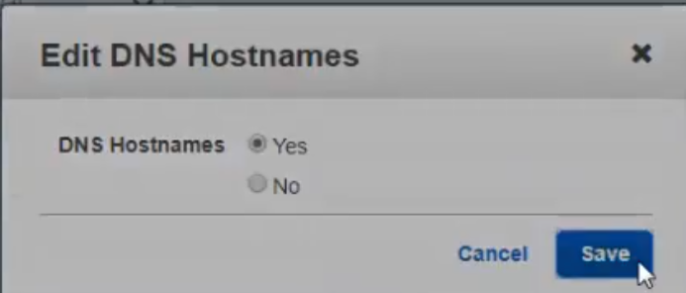

launch an ec2 instance🡪 and I'm going to put one instance in the public subnet and I'm going to put one instance in the private subnet… and I'm going to show you how that communication is going to work..

a.)select the my VPC and I'm going to put it in public 1a

I will assign it an automatic IP address.

**I'm not assigning it an elastic IP I'm just assigning it a dynamic IP..**

I'm going to assign it a role now if you don't know what a role is that's basically some permissions for accessing other services on AWS alright so I'm going giving that some permissions because I need to show you command-line interface.

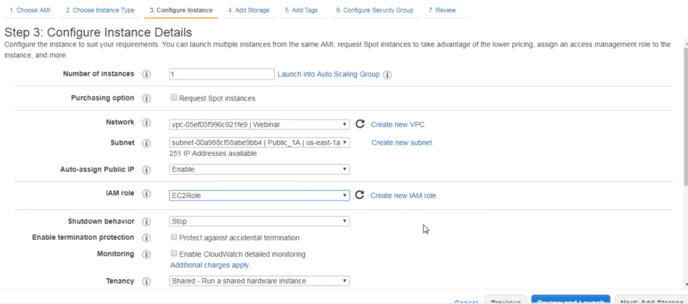

I am also going to launch a second instance… and this instance I will be launching it in the private subnet

So I will do it in private1b … **because the a private system I'm not going to assign a public IP to it.**

**because it's in the private subnet even if it has a public IP is no good**.

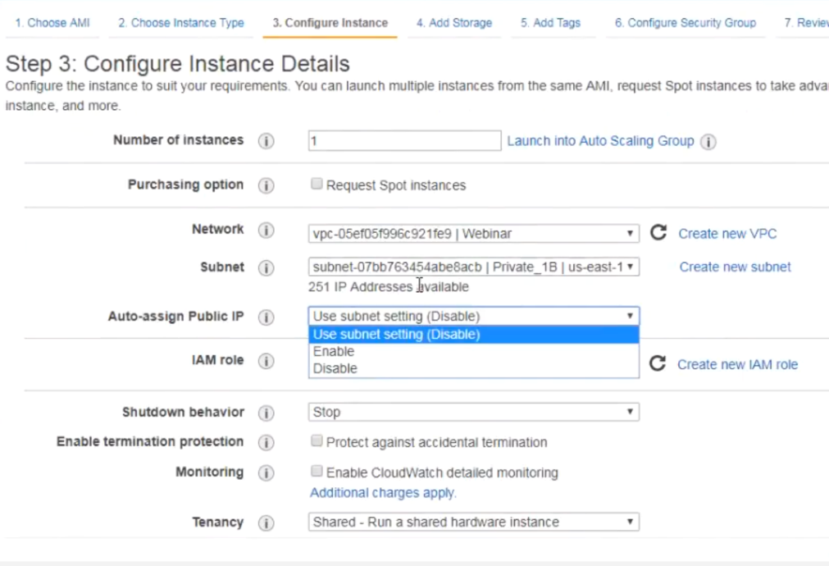

I'm not giving it a role right now…

**I will create a separate security group because I need to show you how communication between security groups actually happen** **so I will do this as private obviously this is a private system** **so I am I'm not going to allow SSH** as of now

1.)first I'm gonna go connect to the public system so as you can see the public system already has an IP address because I assigned auto assign public IP .

public instance-🡪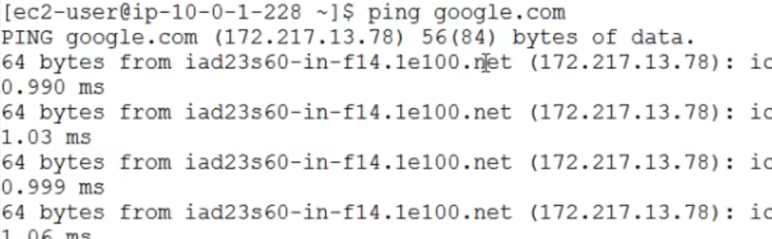

If I try connecting to the private IP of the other system in the private subnet..

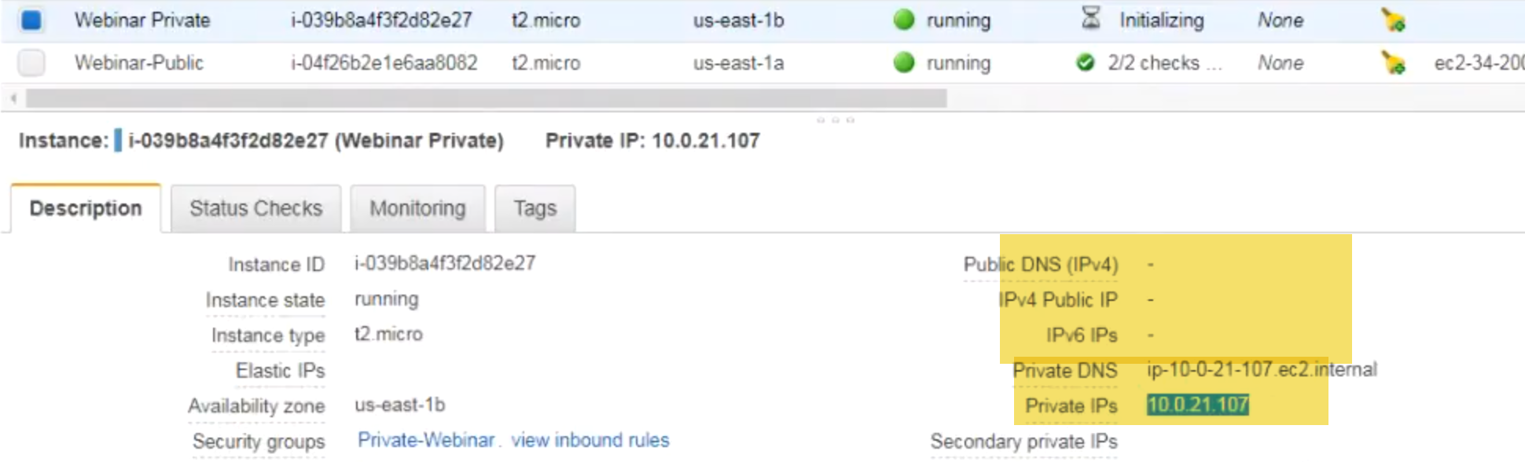

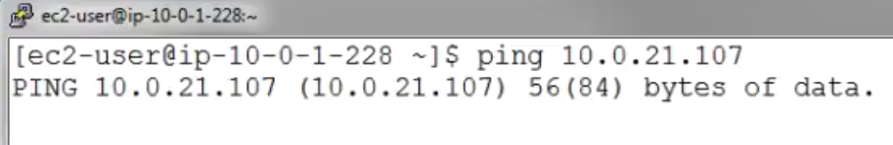

ping it I'm not response. ..Why???

**security groups**:

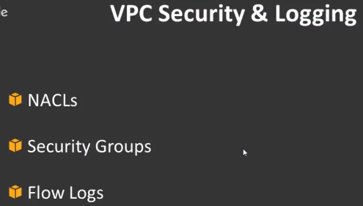

there are two parts to the security on Vpcs

1.)Network access control lists or knackles and the other one

2.) security groups

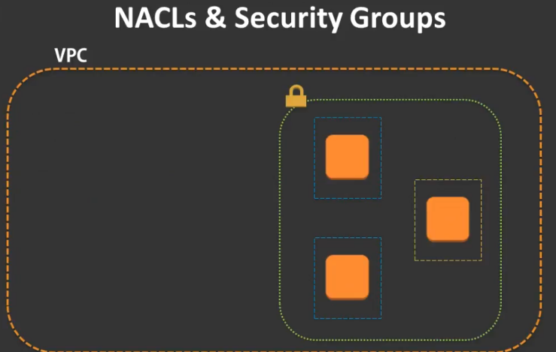

**security groups** :

When we talk about our subnets in VPC, we have our Ec2 inside those subnets.. Each of the instance is actually protected by something called a security group.

**Remember** security group is actually protecting the individual resources that it is assigned to..

**for example** I have another ec2 in the same subnet even if I assign that ec2 to the same security group it is still going to have it is still going to cover that Ec2 instance individually ..

And if I have another instance with a different security group that is obviously going to cover that instance as well individually..

-🡪you have security groups here.

Now security Group1 assigned to two instances and security group 2 to a third instance.

Now remember that the properties of security Group1 is exactly the same.

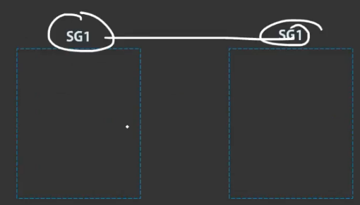

security group1 is secondary Group1..there is no two versions of security group1…It's exactly the same.

If I say allow port 80 Sg1 is going to allow port 80.. this security group1 is also going to allow port 80..

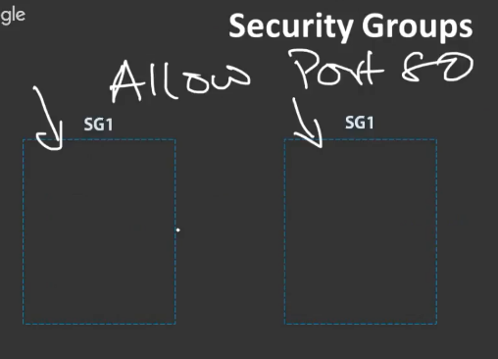

**However remember I told you that each of the instance each of the resources individually covered by the security group**.. what I mean by this is if instance number1 wants to communicate with instance number 2..,technically what's happening is the communication is going out from the security group then it is re-entering the security group..

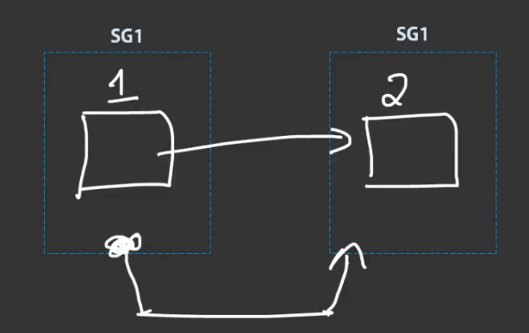

**It's not a internal security group communication** ..It's literally exiting that security group and coming back in now..

If you want system1 and 2 to talk to each other on let's say port 22 which means I want to SSH from system one to system 2..,- **if I have to allow that to happen I have to have a rule in my security group saying that port number 22 should be open for security group one to** security Group one..

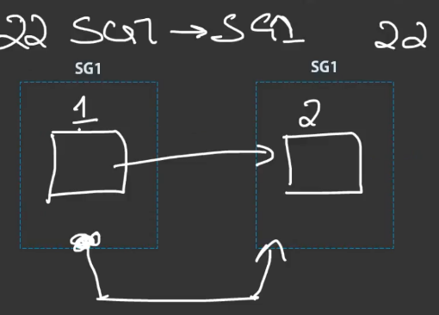

**Although it is the same security group I still need to specify that rule because technically what's happening is if I'm trying to communicate with another instance within the same security group it is actually leaving that security group and re-entering it**

So if I don't specify this like a reentry it's not going to work. 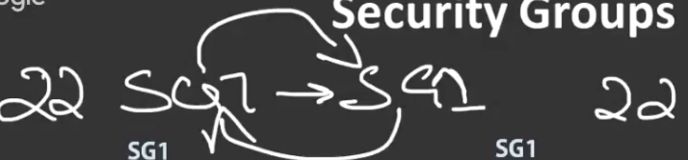

right it's not going to allow the communication to happen so I need to open ports of the same security group to itself otherwise sometimes the internal communication is not going to happen so obviously if I want to do security group two like if I want to do port 22 inbound on security group - I have to allow for 22 from security Group one to security group - I have to allow that all right however if instances between security group also wants to communicate with each other on for 22 I still need to allow that saying security Group one to security Group one should be allowed access to each other all right what's happened right now is my first instance I have one security group and my second instance I have another security group when I am trying to ping this system it's not working because I have not allowed any kind of rules for the security group at this moment one important thing to understand here is that the default of a security group is to allow all outbound deny all inbound that is a default of a security group all right so it's allow all outbound deny all inbound which means you don't have to specify rules for outbound communication because it's all allowed by default of course you can change that however if you want to allow anything inbound you have to specify that separately in order to allow the inbound so my private instance isn't security group to so I should have a rule that allows security group one access for the ICMP port for pinging right otherwise it's not going to ping because it's not going to allow it now the best thing to do here is rather than allowing individual systems it is better you give access to the whole security group for example I have my ec2 instance here in the price the private ec2 instance and I want all the systems to be able to ping it right so I will give inbound access for sg-1 for ICMP protocol then what happens is even if it is this system in s t1 or even if this system in su won it it should still should be able to ping it because it is actually allowing sg-1 and not individual systems so it's always better you allow security groups as a whole rather than individual instances because if you allow the security group as a whole you can allow any group any instance that is associated to the same security group access to the resource I'll just show you this a little bit more detail in the labs here so I have my private and my public one right I will go to my private ec2 instance and see it's actually associated with my private security group so I will go there this is the security group editing option guys so I'll go to inbound now I am in the inbound rule for security group - okay so I am allowing open inbound access on security group - so I will edit that I have an option for ICMP here but I'm not going to do that I'm gonna do all TCP okay because those are systems that internal systems so it's fine I can allow it but of course if you want to specify a certain protocol as well you can do that but I'm not gonna do that for now all right I'm just going to do I can do a custom ICMP rule here if I wish to but I'm just gonna do it all TCP so here I have to specify the source now if I type in SD hey you go it shows me all my security groups so I am allowing any instance in the webinar security group access on all the ports into this security group that's what I am doing I am allowing access to all instances in the webinar security group into this private security group so any instance in this should now be able to talk to each other now one more thing about security groups is that security groups are it can it can actually allow the communication back in on the same port for example I have my ec2 in the private subnet here and let's say I want to talk on 425 okay another easy to hear now this system in sg-1 talks to this system on sg2 on port 25 i have an entry over here that says allow sg-1 access on port 25 so it is able to allow it now when this communication comes back in I don't need to open a port here for 25 I don't need to do that I don't need to do that for security groups because it knows that this is the same communication that went out so it will actually allow that communication back in so I don't need to specify a second inbound rule here it will automatically allow that rule back in for any rule that is specified out obviously it has to be coming from SG to itself all right it should not be coming from any other security group it's not going to allow sd3 to come back around 425 if there is no rule here technically what I'm trying to say here is that if you allow an outbound rule for a particular port by default it will allow that inbound rule as well for the same resource ok not for different resources so if 425 is allowed on SG 2 it'll only accept 425 back in from is due to all right not the other way round so if I go back to my ok so I have allowed that so now let me try pinging it again interesting what did I miss instance is there now private without public private is cloud all inbound SG save now by default SSH is available in all of them this is a networking issue that's why it's not able to ping it right it's it's not a application issue because it's not able to ping so it's it's not responding to the pink right let me check what else is wrong here ten or 0.21 dot one zero seven okay I don't know if this is a secondary group related issue I'll just open that up oh okay I see what I did wrong okay I actually allowed all tcp I should have allowed all traffic because pinging is ICMP protocol so obviously it's not TCP protocol so that so it was not working so I'm allowing all traffic and I'm saving it now if I ping there you go sigh clipping you know probably it was ICMP that so he was not thinking I had selected all tcp instead of all traffic all right okay so let me now show you just give me one second guys let me just get on to the other system you guys please do belt me for a quick minute and doing some booty settings one moment you you you you you you you you you all right guys there's some issue with my pootie settings here so I'll come back to this towards the end of the session so for now what we'll do is I will go ahead and create some s3 endpoints and show it to you how it works okay one thing I want to show you is assigning elastic IPS it is pretty simple guys when you want to assign elastic IPS is core elastic IP allocate a new address okay so you now you got a permanent IP once you get the permanent IP you just need to associate it with an interface all right so I will refresh that I will associate the address so I will associate it with the network interface of either one of the instances or if I select instance I will get the instance ID right so I can assign it to the private one if I wish to but I'm not going to be doing that because obviously my ec2 instance isn't the private subnet second all you need to do is once you do this and you hit associate that system is going to get that IP address I'm just going to show it to you over here once now if I go refresh my ec2 as you can see my private ec2 instance has now an elastic IP attached with it but obviously it's of no use because it's been my private subnet right I cannot make use of that unless I enable and internet route out to the Internet gateway so that's all with regards to elastic IPS if you ever need to assign one obviously you need to disassociate the address if you need to delete it so disassociate and then release it so those are two steps first you acquire the IP and then you associate it and once it's associated you disassociate the IP and then release it right if you want to ever use that endpoints like I mentioned if you want to talk to s3 or something privately that's the way you have to go with end points where you can directly communicate with the service over the endpoint rather than going over the internet to communicate with the s3 buckets for example if I create an endpoint here it's asking what do I want to create the endpoint for so it's either an AW service or I can find other services or there are actually marketplace services so the marketplace service and service provider part guys this is actually part of the part two session because this is talking about using endpoint for public services so that's different for a double your services as you can see here there is DynamoDB and oops so in this list if you look at gateway you have dynamo DB and s3 shown as gateway so these are basically the VPC endpoints and if you look at all of the other ones it says as interface so if you remember I kind of touched on the interfaces as well which is endpoint interfaces which actually creates an elastic network interface inside a subnet so for all the other services which is easy to api's messages elastic load balancing service catalog all of these you can actually do the interface and for s3 and dynamic DB you will have to do the you'll have to do the endpoint alright so I'm not activating this right now because my putti is not proxying on to the second system so I'll come back to this particular section once we have covered with all of the other topics guys because I need to show you getting onto the private system and then making use of this endpoint all right so I will cancel that for now dhcp option sets so this is basically where it allows you to configure the DHCP options now remember there is the IP address which is dot two that is reserved for the DHCP within the AWS network so if you would like to configure custom DHCP settings for example if you want to give your systems or custom host names with your custom domain names you can actually do that if you are also using let's say a Windows system which has which has its own DNS server you can actually read out all your DNS queries to that server and not use this one so this is where you actually configure your DHCP options almost all the time unless you have your own custom DNS server you are not going to touch this you're just going to leave it at the default this will be covered as part of the second section where we are going to show you more advanced in depth we're using a DNS server and how you will route all the DNS I'm sorry how you will route all the DHCP queries to that DNS server alright so if you have any custom DNS servers that you need to mention here you can do that but right now we don't have any custom DNS servers so we'll put that for the next section all right let's talk about nat gateways so we have a private system that does not have communication out to the Internet right so again let me fix that proxy thing with my booty and I will show you this so for the time being guys once I fixed the proxy part I will come back to this but I will continue with the remainder of the theory part I will come back to the practicals once again okay I will pause here for a second and ask if you have any questions for whatever we have covered so far guys okay let me quickly show you the network access control lists so whenever you create your V PC it has certain inbound and outbound rules that are associated with the V PC and these are also associated with your subnets okay these are basically known as knackles network asean this is nothing but you're just specifying what port has what port is allowed inbound and what port is allowed outbound now there are a few difference here between knackles and security groups so I'll just show that you on the slides here the security group like I said it operates on the instance level while the network ACLs actually operate on the subnet level all right the security group allows only allow rules which means you can't do deny rules by default in the security group it's all allow outbound traffic okay which is the third one here allow rules and our bound traffic but it is inbound denied so we have to allow the inbound on the security groups on the network ACLs you have to specify both allow and deny rules like I've already mentioned security group is stateful so return traffic is automatically allowed so you don't need to specify any particular ports for return traffic for that same security groups however for the network SES that's not the case it is stateless you still have to specify which port should be allowed back in in security group it looks at all the rules before it decides what to allow and what to deny in network ACLs it looks at the rules one by one and then either allows it or denies it I will show you this in the console just give me one second the security group applies to the instance only if someone specifies it but the network ACL applies by default no matter whatever you are doing it applies by default to the subnet so when you have a subnet it will apply by default to it security group unless you assign a particular security group to an ec2 instance it does not get applied to that there is no default in that now I'll just show you the narcos here okay so you see these are the inbound and outbound rules for the knockos okay unlike security groups the first rule is allow all traffic inbound ok that is for ipv4 and this is the second rule for ipv6 after that you can see there is a rule which says all traffic deny all traffic deny so there is both an allow and deny rule so how is it still working because in network access control lists it goes line by line so it looks at the first line if there is a rule that allows it it's allowed in ok it doesn't look at all the other rules so when you are actually specifying rules here you have to be careful because you have to put your most highest priority rules on the top because it executes one rules at a time it doesn't look at all the rules together unlike security groups where if you have ten rules to look at all the ten rules together and then there is if if there is a deny it will actually deny it it doesn't look at one by one rule same thing applies for the outbound for network access control list as well where all outbound is by default allowed as well as denied so it looks at the first rule when some communication comes in and it allows it so you have to be careful in terms of specifying the rules here when you do specify the rules here I would suggest that you leave at least some space between the rules for example this is rule number 100 okay and this is rule number one not one don't create another rule with one not two rather create a rule with something like 200 so that if you have to create another rule in the future which is taking higher priority you can create it between 100 and 200 okay so let's say you have a new rule that you created and let's say you created it as one not two but then you have a new rule that you want which is supposed to be higher priority than one not two then you can't do anything you have to literally replace that rule right so that that's that's not a good idea so leave some space between the numbering so do hundred two hundred and fifty then do two hundred then do two fifty so leave some numberings in between so that if you have to plug in a particular rule in the future with a higher priority you can plug it in without actually having to change or delete anything all right any questions between security groups and network access control lists that goes remember the knockos applied directly on the network on the subnet level the security groups apply only on the instance level or on individual resources whether it's your ec2 instance or your RDS instances whichever they are they apply on it individually why elastic IP does not show any IP tab but shown in ipv4 public address you mean to say here there any public IP whether it is a elastic IP that you assign or whether it is a automatically assigned IP that is going to show up here if you have multiple IPS that is also going to show up here so I can attach multiply peace to the system that's always going to show up here so it depends on how you're working with the knackles and the security groups on what applications you are dealing with remember that with security groups there is no deny there is only allow okay so you're just dealing with one side of the things so it doesn't really give you control over the deny part you are because by default everything is denied you are just allowing it one by one right having said that do understand that the security group is the first layer of defense so you have to make sure that your security group is configured as granular as possible rather than your network control network access list you so this is how you add the rules guys just come to the naku you can add another rule here you can give it a rule number like 200 we define what is the protocol or what is the port you define the protocols again you define the port range whether it's a single one or all of them then you define the sources well alright obviously I'm not going to specify that now ok let me quickly wrap up with the remainder of the PPT guys ok so let's look at the two other aspects that I told I will cover in detail in the second section one is VPN and Direct Connect now AWS offers VPN connectivity into your V PC you can actually make the connection using IPSec protocols it can either be static routing or dynamic routing it is a s 128-bit encryption which sha-1 hashing function when you create an IPSec when you create a VPN connection you basically get to IPSec tunnels / VPN connection alright we'll take a closer look at how that essentially translates to so let's say this is your corporate office on the left side and this is your corporate office all your data center or whichever it is and let's say you have an IP address range of 192 168 0 dot 0 slash 16 that is your local network range and let's say you have a V PC with 10.0.0.0 / 16 you will establish a VPN connection between the customer gateway and the virtual private gateway or the vpg once you do that it actually creates two separate tunnels which gets to endpoints on the Virtual Private Gateway all right and the routing is pretty simple the local network will advertise the routes to the VPN on the other side and this VPN connection will advertise the routes this way so now let's see if these systems wants to communicate with one of the systems in your corporate network let's say this one of the instances actually wants to communicate with 192.168.1.5 teen okay so that will come to the router the router will look at the round table and it sees an entry for 192 168 0 dot 0 slash 16 and as you can see the entry actually goes to virtual gateway right so that communication gets forwarded to the virtual gateway that sends it to the customer router then obviously the customer router will send it to the private IP as well it's simple it's same as what you would have with your you know router tables that you create for the internet gateway etcetera right as long as you have the routing information properly mentioned in the load table that should be fine now this is static routes right this is static VPN where you're assigning a certain static route on to your VPN the problem here is that if a tunnel goes down you have to manually work with this because it's not automatically going to fix or fail over to the other tunnel because it's static routes in that sense you can actually do dynamic VPN when you do dynamic VPN what happens essentially is bgp comes into play now for those of you don't know bgp this is actually a networking term which is boto gateway protocol which actually is dynamic okay it's has something called an ASN number an ASN number is kind of the network path so when you look at the number and you say bgp ASN is one seven four nine three this is the number of AWS alright the router that you have know is the route to take to go to that s number right so what happens here with the dynamic VPN is the fact that you don't have to worry about tunnels failing and all of that because bgp has dynamic negotiation if one of the tunnels fail it has the capacity to actually switch over to the other tunnel as well and you don't have to do any static routing here however the concept of Route table still applies where if you want to send traffic between your networks you have to mention as to where it ends up you will have a similar route table obviously in your router over here as well which is all traffic destined for 10.0.0.0 slash 16 it is supposed to go out through the VPN connection alright any questions here on epeans guys I will show you in the console how to create a VPN connection but I was trying to set up a router over here for you for to show you how this works unfortunately that router failed today morning so probably next session I will show you how to do the actually apply the settings on the router so that you can see the VPN connection happening from both sides any questions your on VPN now remember I will be covering this in much more detail in the part 2 section of the webinar hopefully another day what is the benefit of Iping attaching IP directly to ec2 you know ok I will come back to that any questions on the VPN side guys correct one more option you have is resilient depend connectivity which means you are having multiple customer routers you have something called ibgp you have something called ibgp we does internal BGP between all your routers and then you have no connection that is the me BGP connection that goes across to the internet that goes across to be little private gateway so as you can see here you have resilient connectivity between both of your routers so you have four tunnels across two VPN connections here that are terminating on the same virtual private gateway connecting to your V PC when you have multiple V pcs you can still do the same thing where you can have literally multiple VPN connections that are spanning across both your routers that are connecting to both the V pcs right so in this particular webinar it's all it's all been about a single V PC guys so in the next one we will be looking at how to go from one V PC to multiple V pcs right so in that we will discuss more about hub-and-spoke model of V pcs things like transit V pcs Direct Connect gateways etcetera alright so let's talk about Direct Connect Direct Connect is basically an option for you to have physical connectivity directly into AWS what you get is you get a direct dedicated connection that runs directly to the AWS equipment at one of the data centers that it applies is partnered with alright this is not inside the air place data center but it is with one of the partner data centers this is a direct connection into AWS which means it's a private connection whatever communication you are actually doing between your your offices or your data centers and the AWS environment it is going to be private it's not going to go over the internet it is going to go over that dedicated line that you have it reduces your bandwidth costs very much because you are not paying for the public Internet you are just paying for a lower cost that you would pay for the dedicated connection bandwidth now remember it doesn't mean that the actual connection is cheaper because sometimes the dedicated networks actually do cost more in terms of setting however bandwidth costs are much much more lesser than how much you would pay for Internet bandwidth you get consistent network performance because this is a private connection it is not going over the Internet again you have certain SL s that are there to be met in this range the speed can range anywhere between 50 Mbps to 10 gigabits per second so this is how it looks in terms of connecting your data connecting your data center or your office to AWS so there is something called a reconnect location where AWS has their routers that are there in that location now remember this is not the AWS data center rather it's another data center outside of AWS where they have kept their routers waiting for an inter connection from you let's say you also have co-located in the same data center and you have your own routers in that data center you can essentially establish a connection between your data centers and that location then you further establish a connection between your router and the direct connect education so as you can see here the demarcation is the direct connection location all right that is the place where AWS has their own routers which allows you to go across connect on to their network you have to get something called an Noa in order to make that connection happen but once you do that you essentially have a private connection all the way from your data center or your premises directly into AWS this is not going over the Internet you also have another option let's say you of you do not have the resources to actually run your own equipment within the Direct Connect location what you can do is you can actually take the help of some somebody known as a direct connection partner right this let's say somebody like Verizon somebody like C fee in India somebody like Airtel Tata Telecom etc they actually have their own equipment that is already located in the same data centers as the AWS routers what you can do is you can request for a connection with with the direct connect partner so the connection between your premises and the direct connect partner will be taken care by the direct connect partner right basically whether it is something like Tata telecom or Verizon whichever it is you will be paying for this much part they will then make an interconnect into the AWS routers in the direct connect location and you will get access directly like that this actually lowers your cost and and it doesn't actually give you the headache of managing your own equipment there you can connect to any one of the direct location partners when we talk about redundancy in this you can think of it like this where you have two different direct connect locations for example in India there are multiple data connect locations there are Mumbai Bangalore etc so you can actually do a direct connection through two different locations in order to get redundancy well when you talk about redundancy never stop at 1:02 you can definitely go ahead and do multiple redundancy as well which means now you can have four direct connect location for direct connect connections going through two different direct connect locations all right it's a bit forward there all right so I intend to cover this in much more detail in the next webinar guys so hopefully I'll send out the dates and the time frames later on so VPN and reconnect so what's in the next session guys it is basically about going from one V PC to multiple V pcs so when we have 5 10 50 100 200 300 B pcs how do we start dealing with them how do we do transit V pcs where you have all the traffic passing through a single V pcs then connecting to all the other V pcs we look at something called private links as well then obviously we will go in-depth into the hardware and software VPN setups we look at something called between cloud hub we look into more detail about Direct Connect itself something called a connect gateway then we'll talk more about public waves and private waves and global public waves and all of that that comes along with the direct connect setup all right now I just want to quickly demonstrate this V PC pairing guys if hopefully there's some time here ok I want to show you VPC peering so I'm going to create another V PC and let's say I'm going to do a 10 dot 0 dot 0 okay so I have a new V PC there let me create a subnet for that okay I have crater 2v pcs now one is a 10.0.0.0 and one is a 10.1 dot 0 dot 0 ok so I'm going to connect both of these V pieces together and enable V PC peering ok so let me first go ahead and launch an instance in the second V PC okay I need to connect it to an Internet gateway I know we are past you'll time guys just give me another ten minutes and I'll try to wrap this up so I'm just adding a new route on the you sub new VPC route table sending into the Internet gateways so that I can connect with that easy to instance so this is my first instance in my first VPC and this is my second instance in my second VPC so I need to get them both communicating with each other at the moment they won't be talking because they aren't completely different PPC's all right so if I try to ping them they're over you're not going to work so from my first instance if I go ping the one it's obviously not going to work right I haven't opened up the security group but even if I did it's it's not going to work right now so what I'll do is I'll go to my V PC okay I'll go to peering connections I will create a peering connection this is basically I'm connecting to V pieces together I will give it a tag test there is always a requesting V PC and an accepting V PC all right it doesn't really matter the difference here is that if you're actually trying to reappear to V pcs across two different accounts then this matters as to you know who's the requester and who's the acceptor but right now both of these are in our account so it doesn't really matter so I will send the requester as webinar and the other V PC is in my account it is in the same region and I will give the other name and I will create the connection it's as simple as that that's it you just select both the V pcs and that's it now it shows that it isn't pending acceptance I just need to go to the acceptance tab and accept this okay so I'll go to the V PC okay under the peering connection just select the peering and just do accept request accept it that's it so now my peering connection is established however that's definitely not the end of the story because we have to configure our router tables now so now let's go to Route tables and where is the router table of my new system so this is the router table of my second PPC right that is 10.1 dot if I want to send it to my send traffic to my first VPC I need to specify that IP range sure so let's 10.0.0.0 slash 16 yes should I be sending it to guys any idea any idea where I should be sending this traffic to okay it's simple I just need to send it to the peering connection PCX this one I just need to send it to the peering connection right so it will automatically send it to the peering connection save it now I need to do the same thing in the other side as well so I'll go to the other side I will edit it and I will create a route for the other be PC which is 10.1 not 0 0 / 16 any request that goes to that IP range send that to the pairing connection as simple as that so I will save that saved it so the peering connections are saved now I'll just go make sure that the security group is also working I will edit this I will add rule all traffic from obviously it said it's not going to show me because that security group is in a different VPC it's not going to show me the security groups of the other VPC right so in this case I will have to specify the IP address now I'm just going to quickly just change this to just ICMP and I'm going to leave it to anywhere because I don't want to open up the whole thing be more specific let me let me delete that I sent p1 I will do a droll I will do all traffic and I will do custom IP ok what is the IP address of my first instance it is 10 dot 0 dot 1 dot 2 to 8 so that's 10 dot 0 dot one dot o 8 slash remember I cannot just put in a single IP as such I need to specify the CIDRnotation so that's why I'm putting it as slash 32 and I will save it okay so let's try this now there you go guys so it's actually bringing from one network to the other network using the peering connection so this is system 10 dot zero dot one dot two to eight it is pinging system 10.1.1.1 I hope that demonstrates the peering connection any questions here with regards to V PC peering guys you all right I'm going to delete these V pcs and I'm going to show you how you can do things why are the command-line interface so let me delete all my V PC is first okay I need to kill my systems first now it's a security group that is default denial not the knockos knockos is default allow both inbound and outbound you saw the rule in the Knakal rate which was if the first rule was allow all right on both the inbound and outbound so it is it's directly allowable in the that is why we are changing the security group because security group by default is deny all inbound allow all outbound that is why we had to open the port on the security group okay I just want to quickly show you how to do the creation of the V pcs through the command line interface so I'm just waiting for these instances to be terminated okay so let me kill my ABCs I actually should not have killed my first instance because I needed that okay while it's deleting it guys I just want to quickly say that we do have another aw solutions architect batch that is actually starting on Monday so if anyone is actually interested in joining it I think you guys already have the link if you do not you can just go to EECOM dot in slash training and AW solutions architect course it's a 15-day course guys and it's myself that I'm taking it we do have multiple batches so depending on which batch is more full we will go ahead and do that batch maybe two batches also it's a 15-day course guys there is actually a thirty five percent discount on the total of nineteen K for those who are interested in doing the actual Solutions Architect cause it's starting this Monday so if you would like to join in please do let me know before end of day today or tomorrow so that I can get you registered on it alright okay so our V pcs are deleted so now I'll show you how you can actually create them directly from the command interface all right so let me log into this instance right zones this configuring the earliest command-line interface so I'm now ready to pass commands to directly work with regards to creating VP C's or all of this right so let me go to the VP C so you can see there is nothing here except the default V PC right and the subnets are all of the default V PC there's nothing that we created route tables again it's just the default route table for the V PC Internet gateway is also deleted alright so rather than going through the buttons on the console guys you can always directly pass command lines in order to create create anything on AWS literally so in order to create a V PC it's pretty straightforward AWS ec2 create V PC and you specify the side of block alright so this is just one line of command I hit enter there you go the V PC is created i refresh this there you go my V PC you see how quick it was rather than going through all those and selecting different options and doing that and doing this that's it I just pass one line command for the side orange and it created the V PC now that I have the V PC ID I can pass the remaining commands in order to you know create other things on the V PC right so let me show you the other commands this now let's say I want to create a subnet right i specify this command which is create subnet it says create sub gave the VP CID and I give the side a block of the subnet okay before I do this I will show you that there is no current subnet right now if I go to subnet there is no subnet here other than the default ones for the other VPC okay so I'll hit enter on that there you go it's created a subnet there you go 10.10 dot one dot 0 slash 24 let me show you the remaining run let me just copy over the VP CID there are of course additional parameters that you can specify for example here I just created the subnet without specifying the availability zone if I want to I just need to like do availability zone and I specify us - east 1a and I change this right up block to zero there you go it's actually created one more in US east 1a there you go u.s. East 1a right so you can specify additional parameters if you wish to so let me create a route table as well for you to again route table creation pretty simple create route table and pass the vp cid there you go route table is created now if I go to route tables I have a new route table that is created which is not the main the main route table is always there but then I created an additional route table now obviously if I want to create create an Internet gateway as well simple I'll just and to create the Internet gateway a you go my internal gateways created now I need to associate this Internet gateway with my V PC that I have that's also just one line of command is attached Internet gateway Internet gateway ID and V PC ID there you go it's attached so if I now go to my internet gateway as you can see it's created the new internet gate where it's already attached it to my V PC as well now let's go ahead and create let's go and create an entry in the route table alright so let me go to route table let me copy the route table ID which is this it's so clear that I'm creating a route entry inside the route table which is the same thing as I mentioned for our internet gateway which is 0.0.0.0 slash zero and it is going to the gateway ID and is that my internet gateway let me check it's not my internet gateway right past this comment I will just show you the existing route table so under the existing route table there is nothing nothing they are now except for the local road right so I will enter this [Music] small error in the command refresh there you go done it's added the new route and as a final step I will go ahead and attach the route table I will attach a subnet to the route table right so I will take my subnet ID first so I am associating my route table with my subnet right pretty simple so I'll mention the route table ID and I'll mention the subnet ID let me first show you that it is not associated right now so if I go to my route tables subnet associations there is nothing associated as of now all right so I will pass that command there you go the association is done now if I go to route tables and refresh as you can see there is actually the route table Association so we did all of this by just passing four or five lines of command right so you can see how you can actually do this by you know through the command line interface where you can literally manage any service on AWS especially with networking it's much more easier through the command line than going through all of these buttons and clicking and adding certain boxes you might miss some instead you can just run a single command to get a lot of things done obviously you can go more advanced and do things like cloud formation and all of that which is a totally different thing but if you do that like at a single click of a button you can get exactly your VP sees your subnets your route tables your internet you know is everything at one go right you don't need to spend a lot of time trying to manually create it all right guys with that we have come to the end of our current webinar session guys I'd like to thank you for listening in and if you are currently watching this via the YouTube window or if not you can just click on the YouTube window and you can click on the subscribe button so that if at all in the future there is new videos that are added or you know new sessions you can actually get notified of those sessions so please do subscribe also like I've mentioned any of you who are interested in actually doing the full aw solutions architect course I'd be more than happy if you would actually go ahead and register so that we we have a bad starting on Monday all right once again I like to thank you for listening in I will try adding that bit about the private connectivity once I fixed the proxying on my pootie correctly so that it passes the key I actually want to demonstrate it to you how to do the jump host which is going from from the public to the private using the private IP and then trying to reach out to s3 so I'll try to add that to the end of this video later on once I fix that if not I'll post it on another video as well once again guys thank you for listening in and if you do have any questions before we end for the day I'll give you another four to five minutes to clear out any doubts or questions that you have I will be putting out notification area as well as since you have already subscribed guys your you will be part of the mailing list so if at all there is any new sessions coming you will get to know the dates and everything so no worries there we currently don't have devups but hopefully in the next month or two we'll try doing that like I've mentioned guys I do have a company to run so I cannot do trainings 24/7 so I'm just sticking to the Solutions Architect course as of now because what you get from that is C we deal with a lot of clients on a daily basis right and we architects solutions for them so what you get from those course the course is actually that real-time scenarios where we look at those solutions and we talk about how you design those solutions and what are the different scenarios that you would use for different applications or different environments etc right so as of now I'm just sticking to the architect side of things hopefully in the future next month or two once things actually clear up a little bit because we're dealing with a little bit a lot of things right now so once that is done and I find more time I might be able to do a session on DevOps Suresh I would recommend you hit the subscribe button once the video is up you will get the direct notification of the link it should be on the same YouTube channel you can just come to the channel name it's a I CIT learning alright guys so it's touching close to 8 o'clock now sorry we had to extend by another half an hour hopefully in the future for the next session we'll cover a little bit more in depth on the VPN side and the direct connect site also we will discuss about having multiple V pcs like I mentioned things like transit be pcs etc I hope you found this session helpful and informative I would really appreciate it if you could leave some feedback or comments once this video is up and I like to hear back from you if you have any other comments right guys if you have any other feedback I'd love to hear it from you the PPT won't be shared but the video will be available so you can take a look at it alright guys thank you and you all have a good day a wonderful night ahead and for some of you good morning for the rest of the day pappa guys thank you